

Mini Project Online Shopping (Dior)

Multimedia Application (INFS-443)

Name Of Course Teacher: Ms. Ahmed Unisa

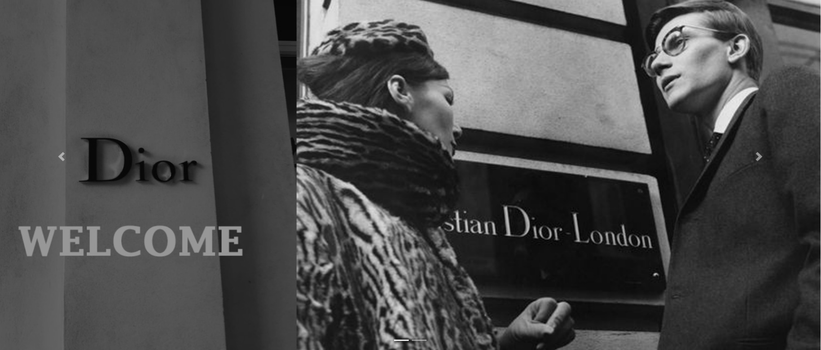

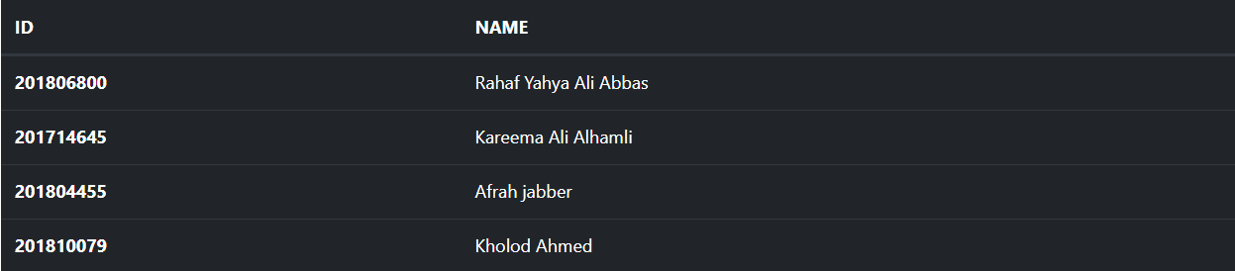

**Introduction**

Dior, the house was founded in 1946 by French fashion designer Christian Dior, who was originally from Normandy. Dior is a symbol of elegance and luxury. Dior’s elegant and fashionable design has been a constant inspiration to the fashion industry for 70 years. Dior is the brand, named after Christian Dior, and deals in the design, sales, and marketing of fashion apparel, accessories, and beauty products. Christian Dior SE (French: [kʁistjɑ̃ djɔʁ]), commonly known as Dior, is a French luxury fashion house controlled and chaired by French businessman Bernard Arnault, who also heads LVMH, the world's largest luxury group. Dior itself holds 42.36% shares of and 59.01% of voting rights within LVMH. Dior to make its offer available to the target audience, Dior employs a mix of demographic and psychographics. Dior uses different targeting strategies to attract and promote a specific group of customers. It has succeeded in positioning itself as a brand that carries a rich heritage while challenging the status quo of fashion and modern society. To position itself as a premium brand, it uses a value-based positioning strategy. A leading company that has remained at the top of fashion's hierarchy for over 70 years, Dior's unique look has influenced the world of fashion since the beginning. Innovative but traditional, Dior maintains its reputation as a creator of recognized haute couture. From their ready-to-wear fashion, leather goods, accessories, or footwear, Dior changed the game forever. To this day, the brand is all around us in some way, shape, or form - even if we don't know it.

**Company History**

Founded by Christian Dior, born in January 1905, the fashion house was established in December 1946 at 30 Avenue Montaigne in Paris. Dior's first collection launched on February 12th for Spring / Summer 1947 at the company's headquarters. An instant success, Harper's Bazaar Editor-In-Chief Carmel Snow strongly believed in Dior's talent. "It's quite a revolution, dear Christian! Your dresses have such a new look," she exclaimed. Thus, the "New Look" became a trademark. Introducing unique silhouettes consisting of shorter, fuller skirts, tighter waists, and accentuated busts - Dior's pieces *were*revolutionary, especially in the 40s. "I wanted my dresses to be 'constructed', molded on the curves of the female body whose contours they would stylish. I accentuated the waist, and the volume of the hips, and I emphasized the bust. To give my designs more hold, I had nearly all the fabrics lined with percale of taffeta, renewing a tradition that had long been abandoned," said Christian Dior.

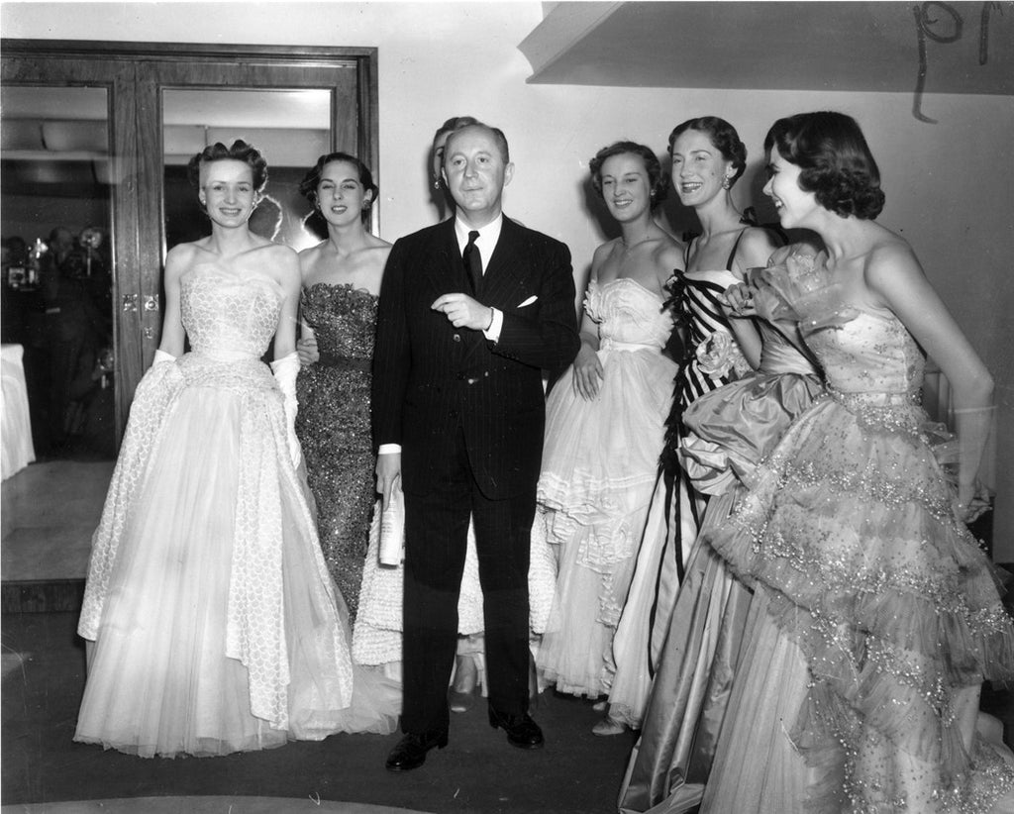

The brand continued to flourish. By the mid-1950s the house of Dior was a highly respected fashion empire. Dior dressed countless celebrities including Marlene Dietrich, Ava Gardner, and members of the royal family.

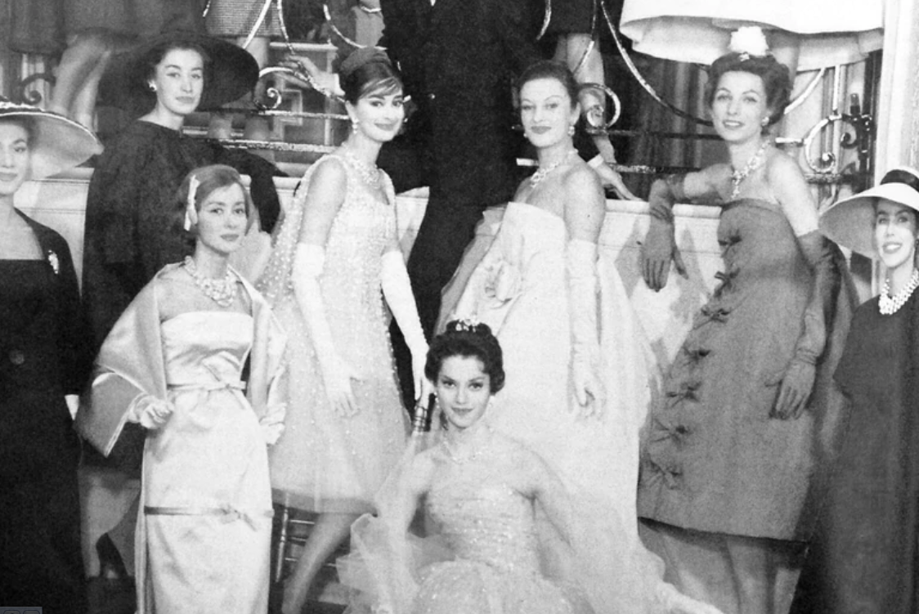

Upon the tragic death of Christian Dior in 1957, 21-year-old Yves Saint Laurent took the creative reigns of the acclaimed fashion house. Saint Laurent kept Christian Dior's legacy alive by using the same fabrics, keeping the proportions and silhouettes relatively similar. However, Saint Laurent's collections featured pieces that were softer, lighter, and easier to wear. Saint Laurent's designs became more daring due to his success at the fashion house until 1960 when his bohemian collection was harshly criticized. Saint Laurent was called up to join the French army, thus forcing him to leave Maison Dior, which raised no objection with the Dior management.

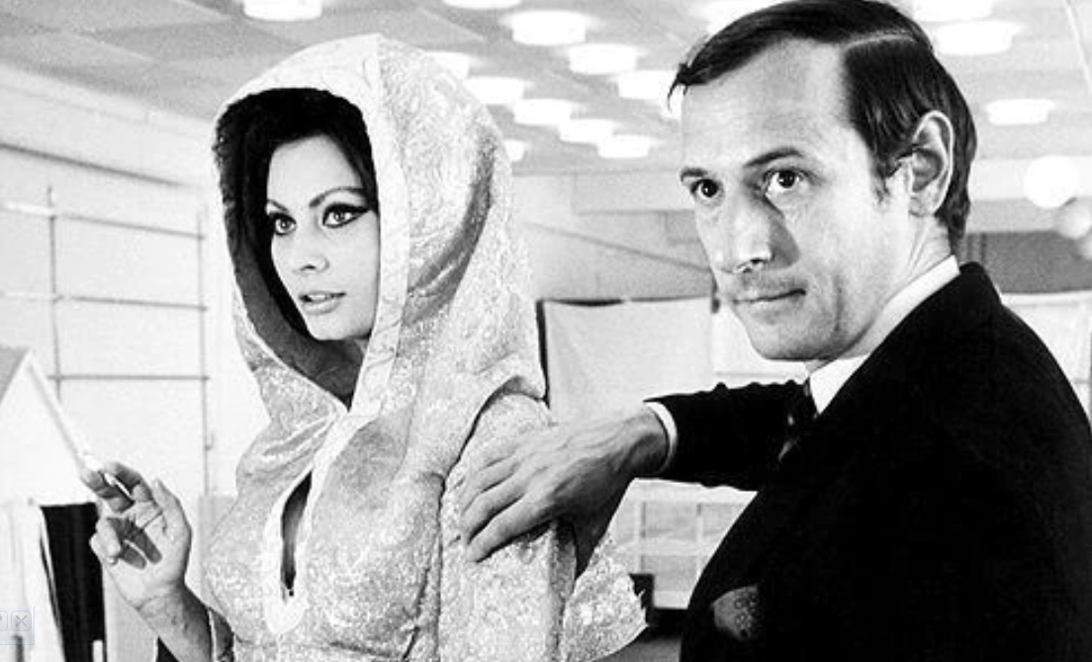

Following the departure of Yves Saint Laurent, Marc Bohan was appointed creative head in the late 1960s. Instilling a more conservative style, he was credited as the man who kept the Dior label "at the forefront of fashion while still producing wearable, elegant clothes" and Women's Wear Daily claimed that Bohan "rescued the firm." In 1967, Bohan's assistant Philippe Guibourgé launched the brand's first French ready-to-wear collection called "Miss Dior."

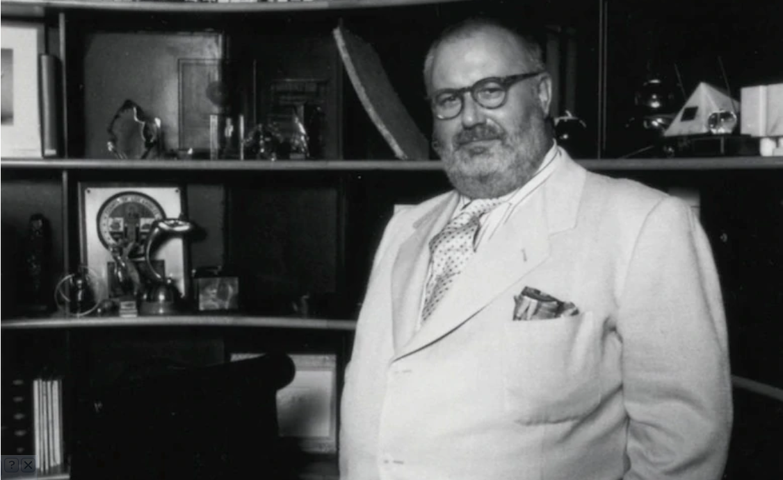

In 1989, Italian-born Gianfranco Ferré replaced Bohan as head designer. As the first non-French designer to take the creative reigns at Dior, Ferré left behind the traditional Dior aesthetic. By 1990, Dior boutiques were opened in upscale New York City, Los Angeles, and Tokyo shopping districts. Also in 1995, Bernadette Chirac (wife of former French President Jacques Chirac) contacted Christian Dior, explaining that she wished to gift the Princess of Wales a unique handbag upon her visit to Paris. The Maison created a structured black bag, unofficially named the Chouchou.

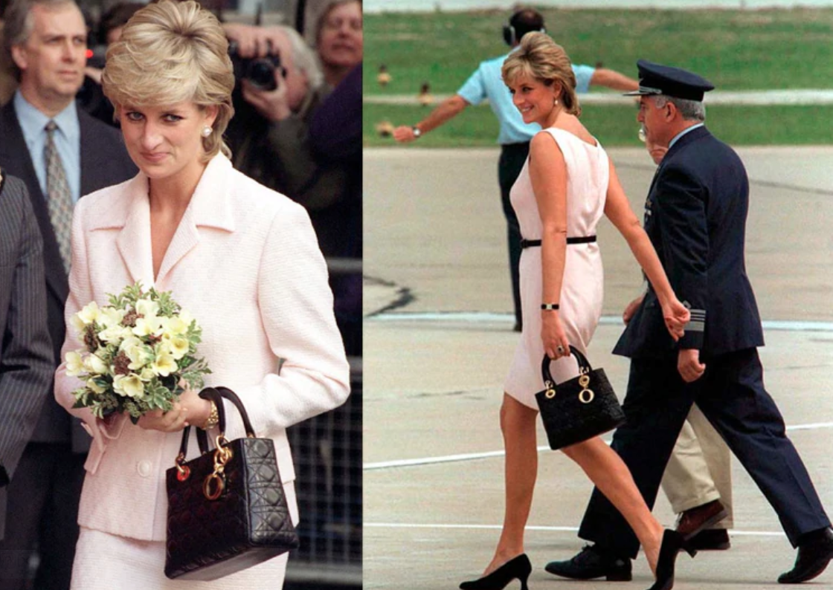

Under the influence of Anna Wintour, Editor-In-Chief of Vogue, Dior appointed John Galliano as creative director in 1997, replacing Gianfranco Ferré. Galliano's collections were somewhat controversial which evoked further interest in the brand, including the "Homeless Show" featured models dressed in newspapers and paper bags and the "S & M" show.

In July 2000, Hedi Slimane succeeded Patrick Lavoix as lead designer for Dior Homme. Although the menswear line was originally founded in 1970 by Marc Bohan, it was no where near as successful as the womenswear line and the boutique was shut down. Slimane re-vamped Dior Homme, giving it a modern, masculine aesthetic. Soon, the label had gained prominent male clientele when Brad Pitt and Mick Jagger were seen wearing it. In 2002, Slimane was awarded the "International Designer of the Year" award by the CFDA. Kris Van Assche was appointed the new creative director of Dior Homme in 2007 after the departure of Hedi Slimane.

By 2011, chaos struck the house of Dior when several accusations were made against John Galliano for making anti-Semitic remarks. The label found itself in a "public relations nightmare." Galliano was, naturally, fired in March just before the debut of his Fall / Winter 2011 collection, which commenced without him.

Bill Gaytten was appointed as the head designer upon the scandalous departure of John Galliano, despite the remaining absence of the artistic director position. Gaytten had previously worked under Galliano for both Dior and the John Galliano label. His first collection for Dior received mostly negative reviews, however in January, Gaytten presented his second haute-couture collection which was much better received.

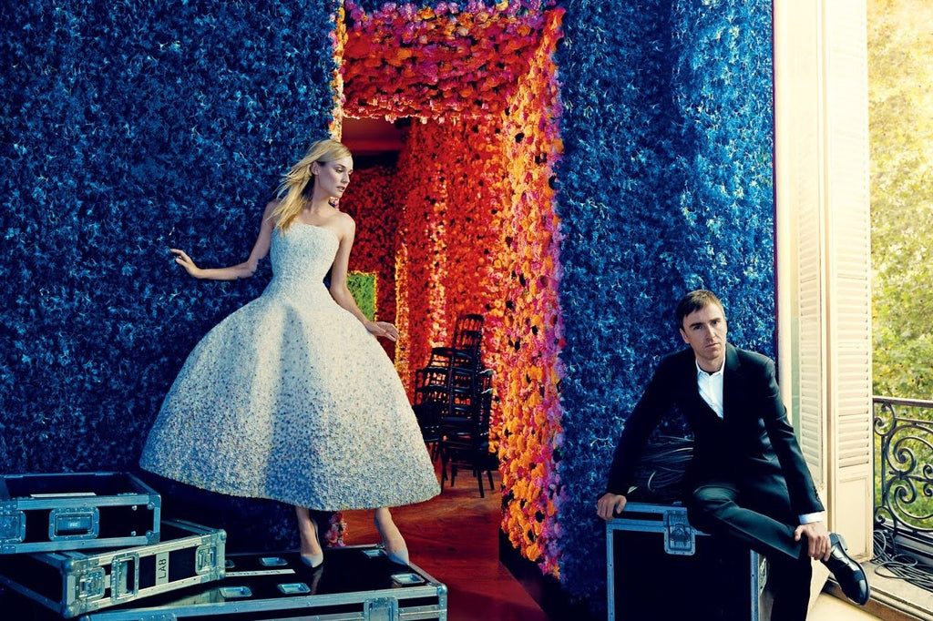

Finally, it was announced on April 11, 2012, that Raf Simons was appointed as the new artistic director of Dior. Acclaimed for his minimalist designs, sharp silhouettes and effortlessly chic aesthetic, Simons was an interesting choice as his work greatly contrasted Galliano's eccentric and flamboyant style. In the hopes of moving forward from the embarrassment Galliano brought to the Dior name, the company was more than eager to go in a new direction. Slimane familiarized himself with haute couture, as the designer had no previous experience in this field and spent much time in the Dior archives. Heid Slimane presented his first collection for Dior on July 2nd, the Fall / Winter 2012 haute-couture line - it thrived. Named "the new couture" by the company, Slimane was the breath of fresh air Dior so desperately needed. His work "made more referenced to Mr. Dior than to the house of Dior" with pieces inspired by Dior's post World War || designs.

1. **Homepage:**

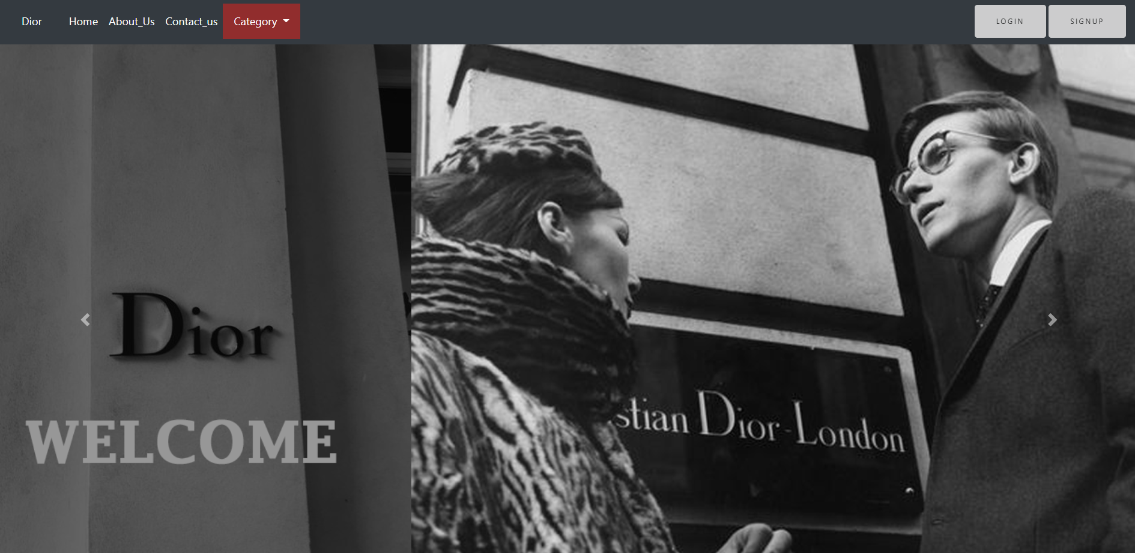

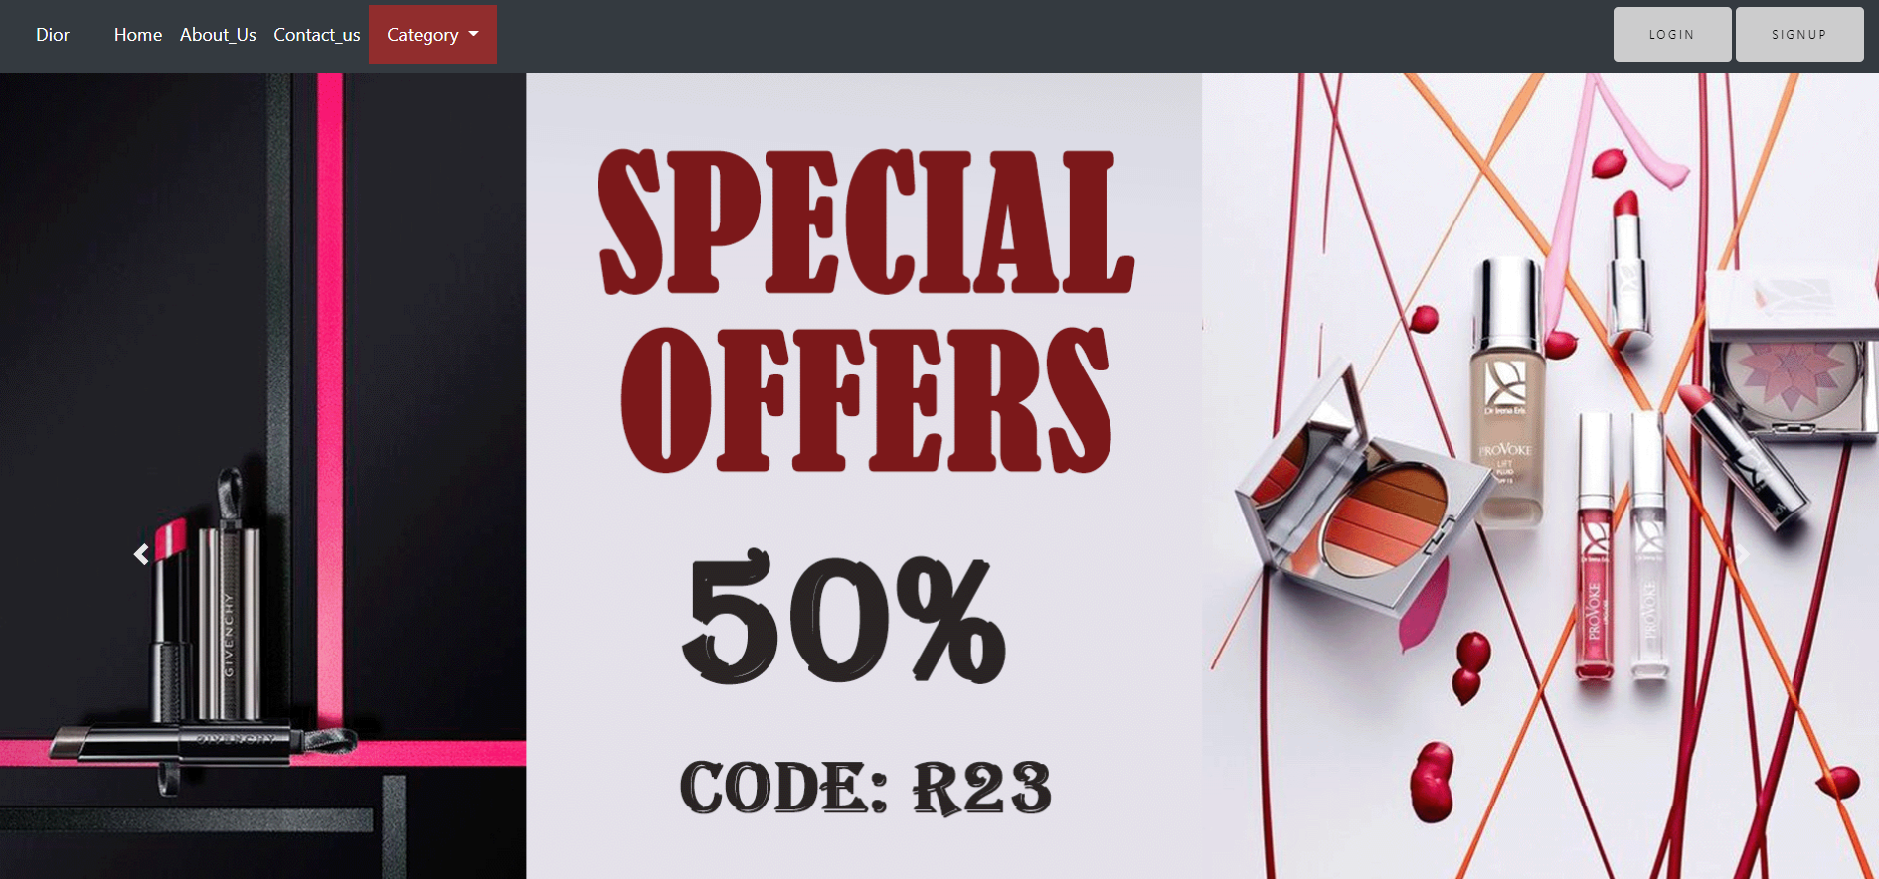

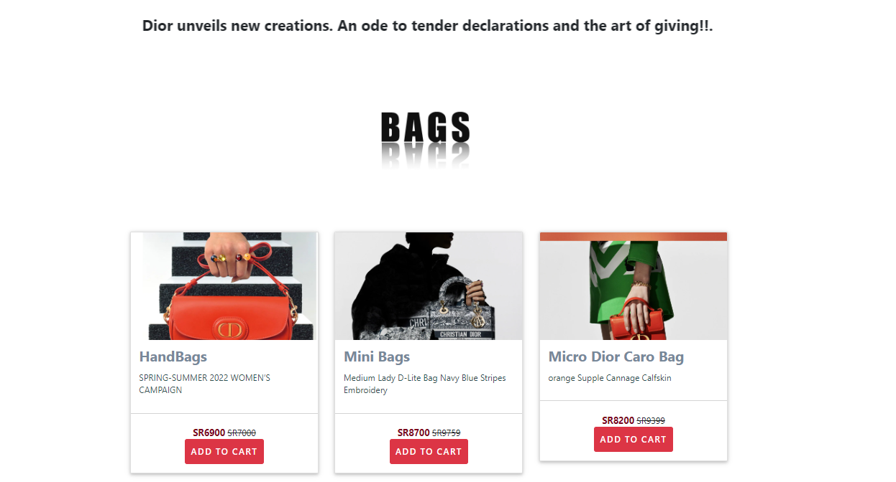

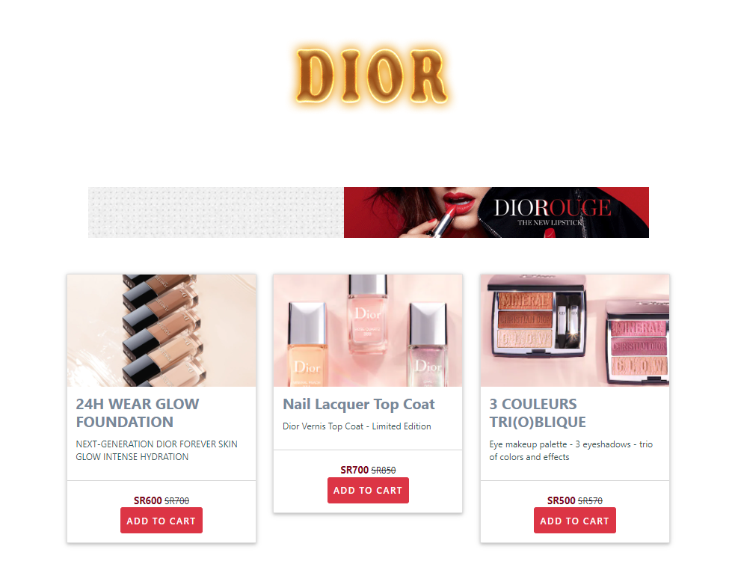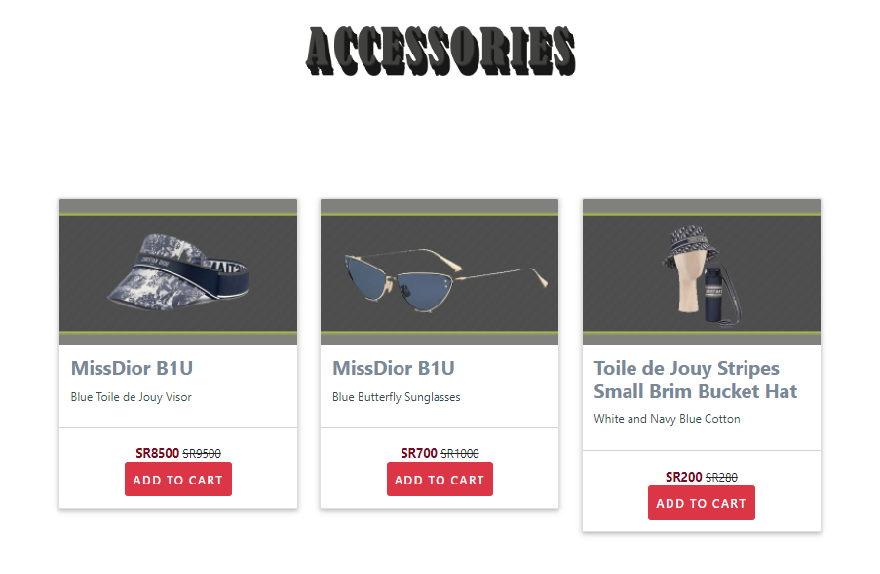

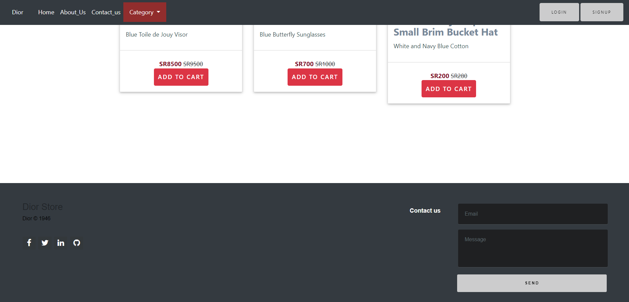

**Code:**

<!doctype html>

<html>

<head>

<meta charset=**"utf-8"**>

<meta name=**"viewport"** content=**"width=device-width, initial-scale=1, shrink-to-fit=no"**>

<link rel=**"stylesheet"** href=**"bootstrap.min.css"**>

<link rel=**"stylesheet"** href=**"css/font-awesome.min.css"**>

<link rel=**"stylesheet"** href=**"https://cdnjs.cloudflare.com/ajax/libs/font-awesome/4.7.0/css/font-awesome.min.css"**>

<script src=**"https://ajax.googleapis.com/ajax/libs/jquery/3.3.1/jquery.min.js"**></script>

<script src=**"https://maxcdn.bootstrapcdn.com/bootstrap/3.3.7/js/bootstrap.min.js"**></script>

<link rel=**"stylesheet"** href=**"style.css"**>

<title>**Dior**</title>

</head>

<body>

<nav class=**"navbar navbar-expand-md navbar-danger fixed-top bg-dark"**>

<a class=**"navbar-brand"** href=**"index.html"**>**Dior**</a>

<button class=**"navbar-toggler"** type=**"button"** data-toggle=**"collapse"** data-target=**"#navbarCollapse"**

aria-controls=**"navbarCollapse"** aria-expanded=**"false"** aria-label=**"Toggle navigation"**>

<span class=**"navbar-toggler-icon"**></span>

</button>

<div class=**"collapse navbar-collapse"** id=**"navbarCollapse"**>

<ul class=**"navbar-nav mr-auto"**>

<li class=**"nav-item active"**>

<a class=**"nav-link"** href=**"index.html"**>**Home** <span class=**"sr-only"**>**(current)**</span></a>

</li>

<li class=**"nav-item"**>

<a class=**"nav-link"** href=**"About.html"**>**About_Us**</a>

</li>

<li class=**"nav-item"**>

<a class=**"nav-link"** href=**"contact.html"**>**Contact_us**</a>

</li>

<li class=**"dropdown"**>

<a class=**"dropdown-toggle"** data-toggle=**"dropdown"** href=**"#"**>**Category**

<span class=**"caret"**></span></a>

<ul class=**"dropdown-menu"**>

<li><a href=**"Women.html"**>**Women's Fashion**</a></li>

<li><a href=**"Men.html"**>**Men's Fashion**</a></li>

<div class=**"dropdown-divider"**> **Kides** & **Baby**</div>

<li><a href=**"index.html"**>**Fragrance** & **Beauty**</a></li>

<li><a href=**"index.html"**>**Make Ups**</a></li>

</ul>

</ul>

<form class=**"form-inline mt-2 mt-md-0"** action=**"login.html"**>

<button class=**"btn btn-outline-danger my-2 my-sm-0"** type=**"submit"**>**Login**</button>

</form>

<form class=**"form-inline mt-2 mt-md-0"** action=**"sign.html"**>

<button class=**"btn btn-outline-danger my-2 my-sm-0"** type=**"submit"**>**Signup**</button>

</form>

</div>

</nav>

<div id=**"carouselExampleIndicators"** class=**"carousel slide"** data-ride=**"carousel"**>

<ol class=**"carousel-indicators"**>

<li data-target=**"#carouselExampleIndicators"** data-slide-to=**"0"** class=**"active"**></li>

<li data-target=**"#carouselExampleIndicators"** data-slide-to=**"1"**></li>

</ol>

<div class=**"carousel-inner"**>

<div class=**"carousel-item active"**>

<img class=**"d-block w-100"** src=**"img/head.gif"** alt=**"First slide"**>

<div class=**"carousel-caption"**>

</div>

</div>

<div class=**"carousel-item"**>

<img class=**"d-block w-100"** src=**"img/head2.gif"** alt=**"Second slide"**>

<div class=**"carousel-caption"**>

</div>

</div>

</div>

<a class=**"carousel-control-prev"** href=**"#carouselExampleIndicators"** role=**"button"** data-slide=**"prev"**>

<span class=**"carousel-control-prev-icon"** aria-hidden=**"true"**></span>

<span class=**"sr-only"**>**Previous**</span>

</a>

<a class=**"carousel-control-next"** href=**"#carouselExampleIndicators"** role=**"button"** data-slide=**"next"**>

<span class=**"carousel-control-next-icon"** aria-hidden=**"true"**></span>

<span class=**"sr-only"**>**Next**</span>

</a>

</div>

<!--carousel!-->

<br><br>

<center>

<table width=**"100%"**><tbody><tr><td>

<marquee direction=**"right"**><font>

<h3><b>**Dior unveils new creations. An ode to tender declarations and the art of giving!!.**</b></h3></font></marquee>

</td></tr></tbody></table>

</center>

<br>

<br>

<br>

<section class=**"wrapper"**>

<div class=**"container-fostrap"**>

<div>

<img src=**"img/BAGS.png"** width=**"300px"**>

</div>

<div class=**"content"**>

<div class=**"container"**>

<div class=**"row"**>

<div class=**"col-xs-12 col-lg-4"**>

<div class=**"card"**>

<a class=**"img-card"** href=**"Women.html"**>

<img src=**"img/bag2.jpg"** />

</a>

<div class=**"card-content"**>

<h4 class=**"card-title"**>

<a href=**"Women.html"**> **HandBags**

</a>

</h4>

<p class=**"uu"**>

**SPRING-SUMMER 2022 WOMEN’S CAMPAIGN**

</p>

</div>

<div class=**"card-read-more"**>

<br>

<span class=**"item_price"**>**SR6900**</span>

<del>**SR7000**</del>

<p><a href=**"Women.html"** class=**"btn btn-danger"** role=**"button"**>**ADD TO CART**</a></p>

</div>

</div>

</div>

<div class=**"col-xs-12 col-lg-4"**>

<div class=**"card"**>

<a class=**"img-card"** href=**"Women.html"**>

<img src=**"img/bag.jpg"** />

</a>

<div class=**"card-content"**>

<h4 class=**"card-title"**>

<a href=**"Women.html"**> **Mini Bags**

</a>

</h4>

<p class=**"uu"**>

**Medium Lady D-Lite Bag Navy Blue Stripes Embroidery**

</p>

</div>

<div class=**"card-read-more"**>

<br>

<span class=**"item_price"**>**SR8700**</span>

<del>**SR9759**</del>

<p><a href=**"Women.html"** class=**"btn btn-danger"** role=**"button"**>**ADD TO CART**</a></p>

</div>

</div>

</div>

<div class=**"col-xs-12 col-lg-4"**>

<div class=**"card"**>

<a class=**"img-card"** href=**"Women.html"**>

<img src=**"img/bag3.jpg"** />

</a>

<div class=**"card-content"**>

<h4 class=**"card-title"**>

<a href=**"Women.html"**> **Micro Dior Caro Bag**

</a>

</h4>

<p class=**"uu"**>

**orange Supple Cannage Calfskin**

</p>

</div>

<div class=**"card-read-more"**>

<br>

<span class=**"item_price"**>**SR8200**</span>

<del>**SR9399**</del>

<p><a href=**"Women.html"** class=**"btn btn-danger"** role=**"button"**>**ADD TO CART**</a></p>

</div>

</div>

</div>

</div>

<br>

<br>

<div>

<img src=**"img/fireDior.png"**>

<img src=**"img/banner.gif"**>

</div>

<br>

<br>

<div class=**"content"**>

<div class=**"container"**>

<div class=**"row"**>

<div class=**"col-xs-12 col-lg-4"**>

<div class=**"card"**>

<a class=**"img-card"** href=**"Makeup.html"**>

<img src=**"img/make.jpg"** />

</a>

<div class=**"card-content"**>

<h4 class=**"card-title"**>

<a href=**"Makeup.html"**>**24H WEAR GLOW FOUNDATION**

</a>

</h4>

<p class=**"uu"**>

**NEXT-GENERATION DIOR FOREVER SKIN GLOW**

**INTENSE HYDRATION** </p>

</p>

</div>

<div class=**"card-read-more"**>

<br>

<span class=**"item_price"**>**SR600**</span>

<del>**SR700**</del>

<p><a href=**"#"** class=**"btn btn-danger"** role=**"button"**>**ADD TO CART**</a></p>

</div>

</div>

</div>

<div class=**"col-xs-12 col-lg-4"**>

<div class=**"card"**>

<a class=**"img-card"** href=**"Makeup.html"**>

<img src=**"img/make2.jpg"** />

</a>

<div class=**"card-content"**>

<h4 class=**"card-title"**>

<a href=**"Makeup.html"**> **Nail Lacquer Top Coat**

<br>

</a>

</h4>

<p class=**"uu"**>

**Dior Vernis Top Coat - Limited Edition** </p>

</div>

<div class=**"card-read-more"**>

<br>

<span class=**"item_price"**>**SR700**</span>

<del>**SR850**</del>

<p><a href=**"#"** class=**"btn btn-danger"** role=**"button"**>**ADD TO CART**</a></p>

</div>

</div>

</div>

<div class=**"col-xs-12 col-lg-4"**>

<div class=**"card"**>

<a class=**"img-card"** href=**"Makeup.html"**>

<img src=**"img/make3.jpg"** />

</a>

<div class=**"card-content"**>

<h4 class=**"card-title"**>

<a href=**"Makeup.html"**> **3 COULEURS TRI(O)BLIQUE**

</a>

<br>

</h4>

<p class=**"uu"**>

**Eye makeup palette - 3 eyeshadows - trio of colors and effects** </p>

</div>

<div class=**"card-read-more"**>

<br>

<span class=**"item_price"**>**SR500**</span>

<del>**SR570**</del>

<p><a href=**"#"** class=**"btn btn-danger"** role=**"button"**>**ADD TO CART**</a></p>

</div>

</div>

</div>

</div>

<div>

<br>

<br>

<img src=**"img/3d.png"** class=**"fostrap-logo"**/>

<br>

</div>

<div class=**"content"**>

<div class=**"container"**>

<div class=**"row"**>

<div class=**"col-xs-12 col-lg-4"**>

<div class=**"card"**>

<a class=**"img-card"** href=**"Women.html"**>

<img src=**"img/acce.gif"** />

</a>

<div class=**"card-content"**>

<h4 class=**"card-title"**>

<a href=**"Women.html"**> **MissDior B1U**

</a>

</h4>

<p class=**"uu"**>

**Blue Toile de Jouy Visor**

</p>

</div>

<div class=**"card-read-more"**>

<br>

<span class=**"item_price"**>**SR8500**</span>

<del>**SR9500**</del>

<p><a href=**"Women.html"** class=**"btn btn-danger"** role=**"button"**>**ADD TO CART**</a></p>

</div>

</div>

</div>

<div class=**"col-xs-12 col-lg-4"**>

<div class=**"card"**>

<a class=**"img-card"** href=**"Women.html"**>

<img src=**"img/acces1.gif"** />

</a>

<div class=**"card-content"**>

<h4 class=**"card-title"**>

<a href=**"Women.html"**> **MissDior B1U**

</a>

</h4>

<p class=**"uu"**>

**Blue Butterfly Sunglasses** </p>

</div>

<div class=**"card-read-more"**>

<br>

<span class=**"item_price"**>**SR700**</span>

<del>**SR1000**</del>

<p><a href=**"Women.html"** class=**"btn btn-danger"** role=**"button"**>**ADD TO CART**</a></p>

</div>

</div>

</div>

<div class=**"col-xs-12 col-lg-4"**>

<div class=**"card"**>

<a class=**"img-card"** href=**"Women.html"**>

<img src=**"img/acce2.gif"** />

</a>

<div class=**"card-content"**>

<h4 class=**"card-title"**>

<a href=**"Women.html"**>**Toile de Jouy Stripes Small Brim Bucket Hat**

</a>

</h4>

<p class=**"uu"**>

**White and Navy Blue Cotton** </p>

</div>

<div class=**"card-read-more"**>

<br>

<span class=**"item_price"**>**SR200**</span>

<del>**SR280**</del>

<p><a href=**"Women.html"** class=**"btn btn-danger"** role=**"button"**>**ADD TO CART**</a></p>

</div>

</div>

</div>

</div>

</div>

<br>

<br>

</section>

<footer class=**"footer-distributed"**>

<div class=**"footer-left"**>

<h4>**Dior Store**</h4>

<p class=**"footer-company-name"** >**Dior** &copy; **1946**</p>

<div class=**"footer-icons"**>

<a href=**"#"**><i class=**"fa fa-facebook"**></i></a>

<a href=**"#"**><i class=**"fa fa-twitter"**></i></a>

<a href=**"#"**><i class=**"fa fa-linkedin"**></i></a>

<a href=**"#"**><i class=**"fa fa-github"**></i></a>

</div>

<br>

</div>

<div class=**"footer-right"**>

<p>**Contact us**

</p>

<form action=**"index.html"** method=**"post"**>

<input type=**"text"** name=**"email"** placeholder=**"Email"** />

<textarea name=**"message"** placeholder=**"Message"**></textarea>

<button class=**"btn btn-outline-danger my-2 my-sm-0"** type=**"submit"**>**Send**</button>

</form>

</div>

</footer>

<script src=**"js/jquery.min.js"**></script>

<script src=**"https://cdnjs.cloudflare.com/ajax/libs/popper.js/1.12.9/umd/popper.min.js"**></script>

<script src=**"js/bootstrap.min.js"**></script>

</body>

</html>

1. **About us:**

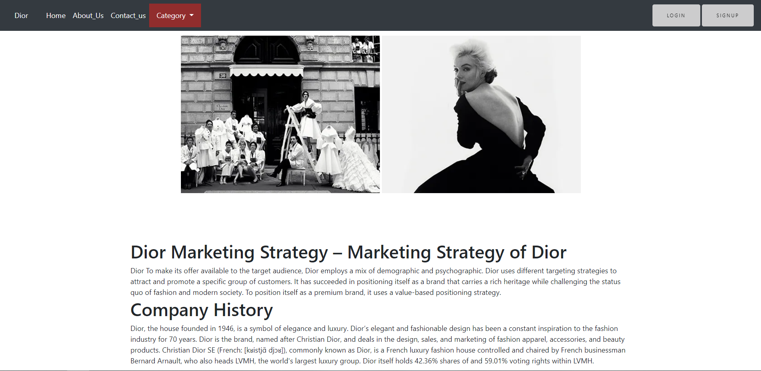

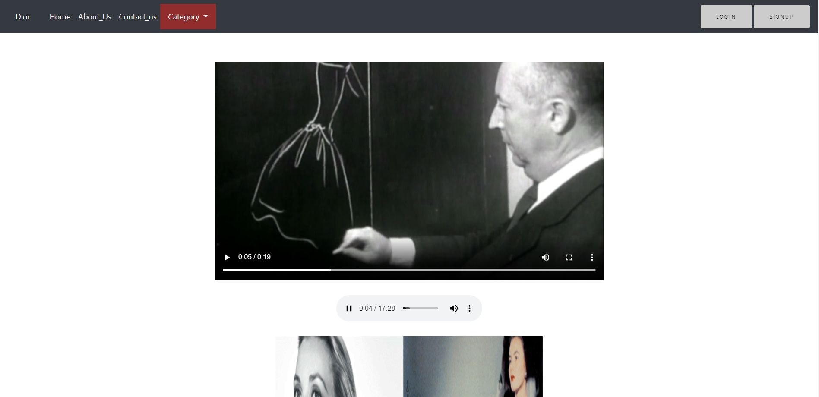

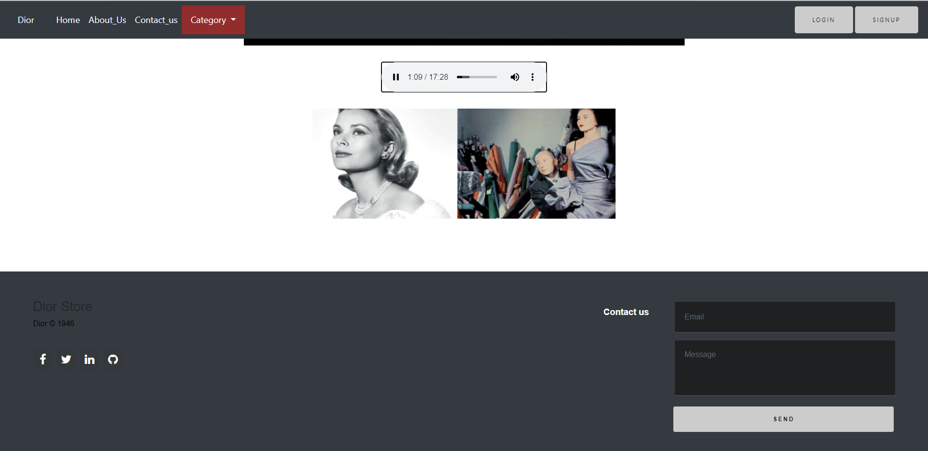

**Code:**

<!doctype html>

<html>

<head>

<meta charset=**"utf-8"**>

<meta name=**"viewport"** content=**"width=device-width, initial-scale=1, shrink-to-fit=no"**>

<link rel=**"stylesheet"** href=**"bootstrap.min.css"**>

<link rel=**"stylesheet"** href=**"css/font-awesome.min.css"**>

<link rel=**"stylesheet"** href=**"https://cdnjs.cloudflare.com/ajax/libs/font-awesome/4.7.0/css/font-awesome.min.css"**>

<script src=**"https://ajax.googleapis.com/ajax/libs/jquery/3.3.1/jquery.min.js"**></script>

<script src=**"https://maxcdn.bootstrapcdn.com/bootstrap/3.3.7/js/bootstrap.min.js"**></script>

<link rel=**"stylesheet"** href=**"style.css"**>

<title>**Dior**</title>

</head>

<body>

<nav class=**"navbar navbar-expand-md navbar-danger fixed-top bg-dark"**>

<a class=**"navbar-brand"** href=**"index.html"**>**Dior**</a>

<button class=**"navbar-toggler"** type=**"button"** data-toggle=**"collapse"** data-target=**"#navbarCollapse"** aria-controls=**"navbarCollapse"** aria-expanded=**"false"** aria-label=**"Toggle navigation"**>

<span class=**"navbar-toggler-icon"**></span>

</button>

<div class=**"collapse navbar-collapse"** id=**"navbarCollapse"**>

<ul class=**"navbar-nav mr-auto"**>

<li class=**"nav-item active"**>

<a class=**"nav-link"** href=**"index.html"**>**Home** <span class=**"sr-only"**>**(current)**</span></a>

</li>

<li class=**"nav-item"**>

<a class=**"nav-link"** href=**"About.html"**>**About_Us**</a>

</li>

<li class=**"nav-item"**>

<a class=**"nav-link"** href=**"contact.html"**>**Contact_us**</a>

</li>

<li class=**"dropdown"**>

<a class=**"dropdown-toggle"** data-toggle=**"dropdown"** href=**"#"**>**Category**

<span class=**"caret"**></span></a>

<ul class=**"dropdown-menu"**>

<li><a href=**"Women.html"**>**Women's Fashion**</a></li>

<li><a href=**"Men.html"**>**Men's Fashion**</a></li>

<div class=**"dropdown-divider"**> **Kides** & **Baby**</div>

<li><a href=**"index.html"**>**Fragrance** & **Beauty**</a></li>

<li><a href=**"index.html"**>**Make Ups**</a></li>

</ul>

</ul>

<form class=**"form-inline mt-2 mt-md-0"** action=**"login.html"**>

<button class=**"btn btn-outline-danger my-2 my-sm-0"** type=**"submit"**>**Login**</button>

</form>

<form class=**"form-inline mt-2 mt-md-0"** action=**"sign.html"**>

<button class=**"btn btn-outline-danger my-2 my-sm-0"** type=**"submit"**>**Signup**</button>

</form>

</div>

</nav>

<div id=**"carouselExampleIndicators"** class=**"carousel slide"** data-ride=**"carousel"**>

<ol class=**"carousel-indicators"**>

<li data-target=**"#carouselExampleIndicators"** data-slide-to=**"0"** class=**"active"**></li>

<li data-target=**"#carouselExampleIndicators"** data-slide-to=**"1"**></li>

</ol>

<div class=**"carousel-inner"**>

<div class=**"carousel-item active"**>

<img class=**"d-block w-100"** src=**"img/head.gif"** alt=**"First slide"**>

<div class=**"carousel-caption"**>

</div>

</div>

<div class=**"carousel-item"**>

<img class=**"d-block w-100"** src=**"img/head2.gif"** alt=**"Second slide"**>

<div class=**"carousel-caption"**>

</div>

</div>

</div>

<a class=**"carousel-control-prev"** href=**"#carouselExampleIndicators"** role=**"button"** data-slide=**"prev"**>

<span class=**"carousel-control-prev-icon"** aria-hidden=**"true"**></span>

<span class=**"sr-only"**>**Previous**</span>

</a>

<a class=**"carousel-control-next"** href=**"#carouselExampleIndicators"** role=**"button"** data-slide=**"next"**>

<span class=**"carousel-control-next-icon"** aria-hidden=**"true"**></span>

<span class=**"sr-only"**>**Next**</span>

</a>

</div>

<!--carousel!-->

<br>

<center>

<img src=**"img/Story.webp"**>

<img src=**"img/Story1.webp"**>

</center>

<br>

<br>

<br>

<div class=**"container"**>

<p>

<h1>**Dior Marketing Strategy – Marketing Strategy of Dior**</h1>

**Dior To make its offer available to the target audience, Dior employs a mix of demographic and psychographic.**

**Dior uses different targeting strategies to attract and promote a specific group of customers.**

**It has succeeded in positioning itself as a brand that carries a rich heritage while challenging the status quo of fashion and modern society. To position itself as a premium brand, it uses a value-based positioning strategy.**

<h1>**Company History**</h1>

**Dior, the house founded in 1946, is a symbol of elegance and luxury. Dior’s elegant and fashionable design has been a constant inspiration to the fashion industry for 70 years. Dior is the brand, named after Christian Dior, and deals in the design, sales, and marketing of fashion apparel, accessories, and beauty products.**

**Christian Dior SE (French: [kʁistjɑ̃ djɔʁ]), commonly known as Dior, is a French luxury fashion house controlled and chaired by French businessman Bernard Arnault, who also heads LVMH, the world's largest luxury group. Dior itself holds 42.36% shares of and 59.01% voting rights within LVMH.**

</p>

<center>

<br><br>

<video width=**"800"** controls>

<source src=**"Dior.mp4"** type=**"video/mp4"**>

<source src=**"1.ogg"** type=**"video/ogg"**>

</video>

<br>

<br><audio width=**"500"** controls>

<source src=**"1.oog"** type=**"audio/ogg"**>

<source src=**"Dior.mp3"** type=**"audio/mpeg"**>

</audio>

<br>

<br>

<img src=**"img/Story3.gif"** name=**"slide"** height=600 width=675 border=5>

<Script>

**var** i**=**600**;**

**var** j**=**50**;**

**var** zoomspeed**=**500**;**

**function** zooming**()**

**{**

**if(**i**==**600**)**

**{**

k**=**0**;**

**}**

**if(**i**==**0**)**

**{**

k**=**1**;**

**}**

**if(**k**==**0**)**

**{**

document.images.slide.height**=**i**;**

i**=**i**-**j**;**

**}**

**else**

**{**

document.images.slide.width**=**i**;**

document.images.slide.height**=**i**;**

i**=**i**+**j**;**

**}**

setTimeout**(**"zooming()"**,** zoomspeed**);**

**}**

zooming**();**

</SCRIPT>

</center>

</div>

<footer class=**"footer-distributed"**>

<div class=**"footer-left"**>

<h4>**Dior Store**</h4>

<p class=**"footer-company-name"** >**Dior** &copy; **1946**</p>

<div class=**"footer-icons"**>

<a href=**"#"**><i class=**"fa fa-facebook"**></i></a>

<a href=**"#"**><i class=**"fa fa-twitter"**></i></a>

<a href=**"#"**><i class=**"fa fa-linkedin"**></i></a>

<a href=**"#"**><i class=**"fa fa-github"**></i></a>

</div>

<br>

</div>

<div class=**"footer-right"**>

<p>**Contact us**

</p>

<form action=**"index.html"** method=**"post"**>

<input type=**"text"** name=**"email"** placeholder=**"Email"** />

<textarea name=**"message"** placeholder=**"Message"**></textarea>

<button class=**"btn btn-outline-danger my-2 my-sm-0"** type=**"submit"**>**Send**</button>

</form>

</div>

</footer>

<script src=**"js/jquery.min.js"**></script>

<script src=**"https://cdnjs.cloudflare.com/ajax/libs/popper.js/1.12.9/umd/popper.min.js"**></script>

<script src=**"js/bootstrap.min.js"**></script>

</body>

</html>

1. **Contact Us:**

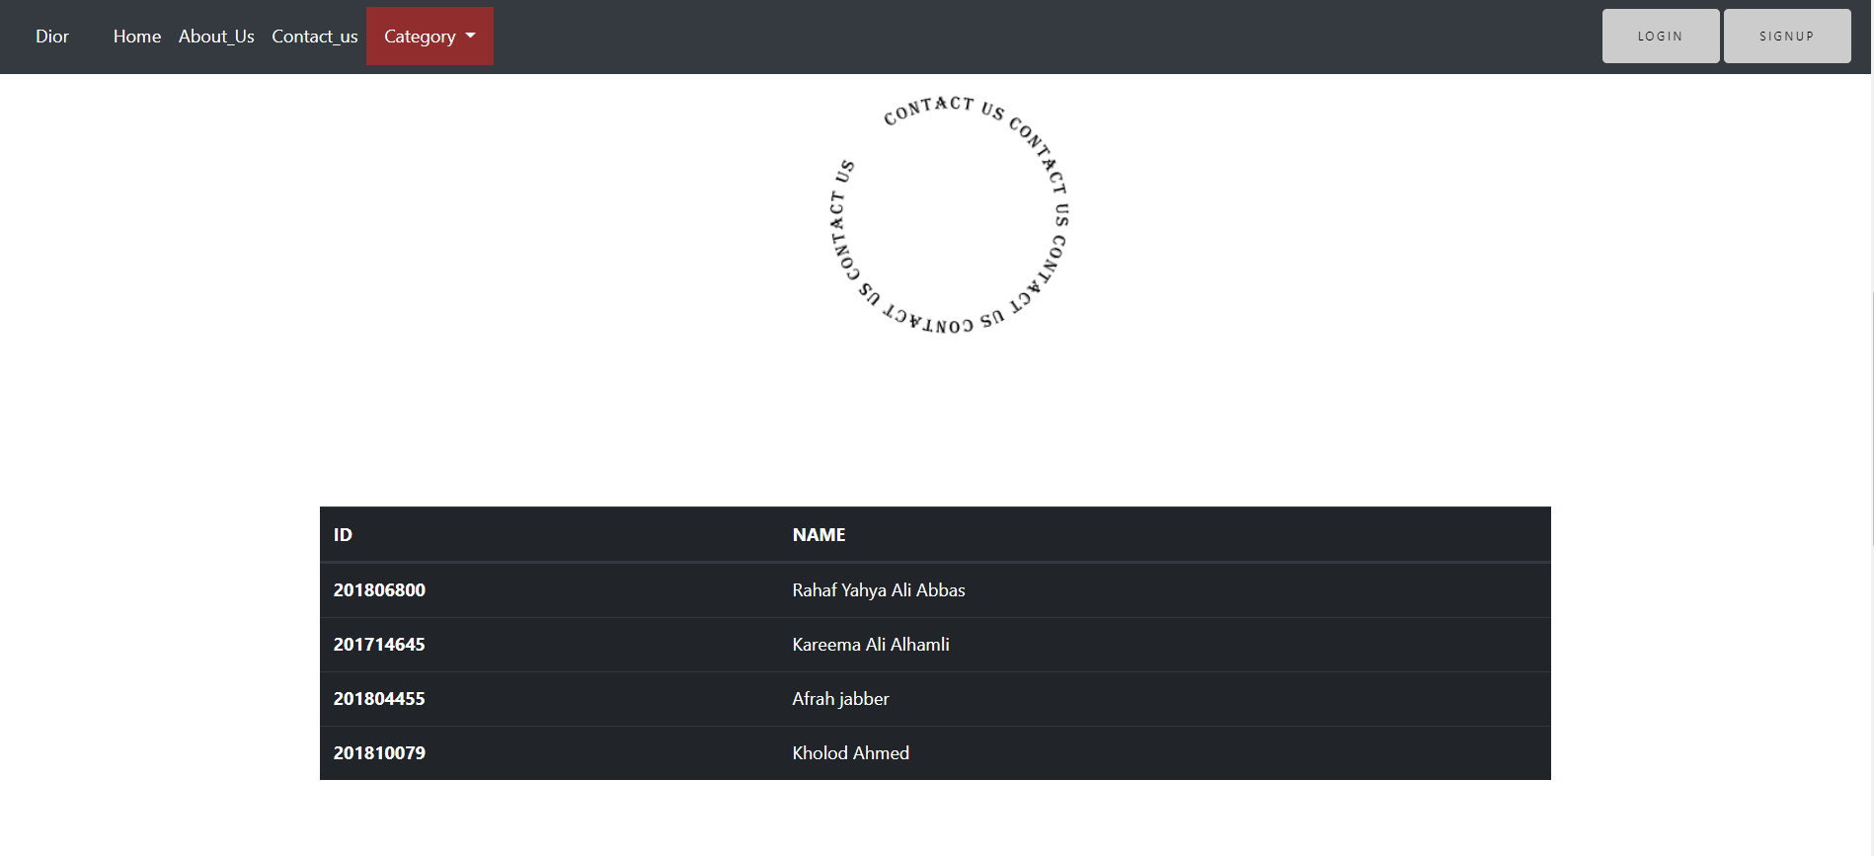

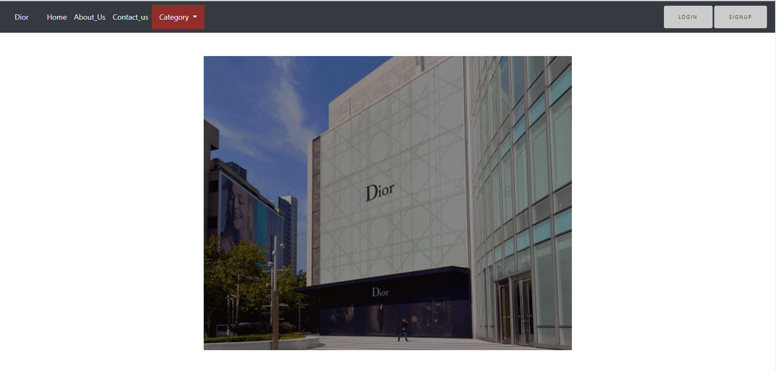

**Code:**

<!doctype html>

<html>

<head>

<meta charset=**"utf-8"**>

<meta name=**"viewport"** content=**"width=device-width, initial-scale=1, shrink-to-fit=no"**>

<link rel=**"stylesheet"** href=**"bootstrap.min.css"**>

<link rel=**"stylesheet"** href=**"css/font-awesome.min.css"**>

<link rel=**"stylesheet"** href=**"https://cdnjs.cloudflare.com/ajax/libs/font-awesome/4.7.0/css/font-awesome.min.css"**>

<script src=**"https://ajax.googleapis.com/ajax/libs/jquery/3.3.1/jquery.min.js"**></script>

<script src=**"https://maxcdn.bootstrapcdn.com/bootstrap/3.3.7/js/bootstrap.min.js"**></script>

<link rel=**"stylesheet"** href=**"style.css"**>

<title>**Dior**</title>

</head>

<body>

<nav class=**"navbar navbar-expand-md navbar-danger fixed-top bg-dark"**>

<a class=**"navbar-brand"** href=**"index.html"**>**Dior**</a>

<button class=**"navbar-toggler"** type=**"button"** data-toggle=**"collapse"** data-target=**"#navbarCollapse"** aria-controls=**"navbarCollapse"** aria-expanded=**"false"** aria-label=**"Toggle navigation"**>

<span class=**"navbar-toggler-icon"**></span>

</button>

<div class=**"collapse navbar-collapse"** id=**"navbarCollapse"**>

<ul class=**"navbar-nav mr-auto"**>

<li class=**"nav-item active"**>

<a class=**"nav-link"** href=**"index.html"**>**Home** <span class=**"sr-only"**>**(current)**</span></a>

</li>

<li class=**"nav-item"**>

<a class=**"nav-link"** href=**"About.html"**>**About_Us**</a>

</li>

<li class=**"nav-item"**>

<a class=**"nav-link"** href=**"contact.html"**>**Contact_us**</a>

</li>

<li class=**"dropdown"**>

<a class=**"dropdown-toggle"** data-toggle=**"dropdown"** href=**"#"**>**Category**

<span class=**"caret"**></span></a>

<ul class=**"dropdown-menu"**>

<li><a href=**"Women.html"**>**Women's Fashion**</a></li>

<li><a href=**"Men.html"**>**Men's Fashion**</a></li>

<div class=**"dropdown-divider"**> **Kides** & **Baby**</div>

<li><a href=**"index.html"**>**Fragrance** & **Beauty**</a></li>

<li><a href=**"index.html"**>**Make Ups**</a></li>

</ul>

</ul>

<form class=**"form-inline mt-2 mt-md-0"** action=**"login.html"**>

<button class=**"btn btn-outline-danger my-2 my-sm-0"** type=**"submit"**>**Login**</button>

</form>

<form class=**"form-inline mt-2 mt-md-0"** action=**"sign.html"**>

<button class=**"btn btn-outline-danger my-2 my-sm-0"** type=**"submit"**>**Signup**</button>

</form>

</div>

</nav>

<div id=**"carouselExampleIndicators"** class=**"carousel slide"** data-ride=**"carousel"**>

<ol class=**"carousel-indicators"**>

<li data-target=**"#carouselExampleIndicators"** data-slide-to=**"0"** class=**"active"**></li>

<li data-target=**"#carouselExampleIndicators"** data-slide-to=**"1"**></li>

</ol>

<div class=**"carousel-inner"**>

<div class=**"carousel-item active"**>

<img class=**"d-block w-100"** src=**"img/head.gif"** alt=**"First slide"**>

<div class=**"carousel-caption"**>

</div>

</div>

<div class=**"carousel-item"**>

<img class=**"d-block w-100"** src=**"img/head2.gif"** alt=**"Second slide"**>

<div class=**"carousel-caption"**>

</div>

</div>

</div>

<a class=**"carousel-control-prev"** href=**"#carouselExampleIndicators"** role=**"button"** data-slide=**"prev"**>

<span class=**"carousel-control-prev-icon"** aria-hidden=**"true"**></span>

<span class=**"sr-only"**>**Previous**</span>

</a>

<a class=**"carousel-control-next"** href=**"#carouselExampleIndicators"** role=**"button"** data-slide=**"next"**>

<span class=**"carousel-control-next-icon"** aria-hidden=**"true"**></span>

<span class=**"sr-only"**>**Next**</span>

</a>

</div>

<!--carousel!-->

<center>

<img src=**"img/text-defferent-shape.png"** width=**"350"**>

</center>

<br>

<br>

<br>

<div class=**"container"**>

<table class=**"table table-dark"**>

<thead>

<tr>

<th scope=**"col"**>**ID**</th>

<th scope=**"col"**>**NAME**</th>

</tr>

</thead>

<tbody>

<tr>

<th scope=**"row"**>**201806800**</th>

<td>**Rahaf Yahya Ali Abbas**

</td>

</tr>

<tr>

<th scope=**"row"**>**201714645**</th>

<td>**Kareema Ali Alhamli**

</td>

</tr>

<tr>

<th scope=**"row"**>**201804455**</th>

<td>**Afrah jabber**

</td>

</tr>

<tr>

<th scope=**"row"**>**201810079**</th>

<td>**Kholod Ahmed**

</td>

</tr>

</tbody>

</table>

<br>

<br>

<br>

<center><img src=**"img/day-night.gif"** width=**"800px"**></center>

</div>

<br>

<br>

<br>

<footer class=**"footer-distributed"**>

<div class=**"footer-left"**>

<h4>**Dior Store**</h4>

<p class=**"footer-company-name"** >**Dior** &copy; **1946**</p>

<div class=**"footer-icons"**>

<a href=**"#"**><i class=**"fa fa-facebook"**></i></a>

<a href=**"#"**><i class=**"fa fa-twitter"**></i></a>

<a href=**"#"**><i class=**"fa fa-linkedin"**></i></a>

<a href=**"#"**><i class=**"fa fa-github"**></i></a>

</div>

<br>

</div>

<div class=**"footer-right"**>

<p>**Contact us**

</p>

<form action=**"index.html"** method=**"post"**>

<input type=**"text"** name=**"email"** placeholder=**"Email"** />

<textarea name=**"message"** placeholder=**"Message"**></textarea>

<button class=**"btn btn-outline-danger my-2 my-sm-0"** type=**"submit"**>**Send**</button>

</form>

</div>

</footer>

<script src=**"js/jquery.min.js"**></script>

<script src=**"https://cdnjs.cloudflare.com/ajax/libs/popper.js/1.12.9/umd/popper.min.js"**></script>

<script src=**"js/bootstrap.min.js"**></script>

</body>

</html>

1. **Women's fashion**

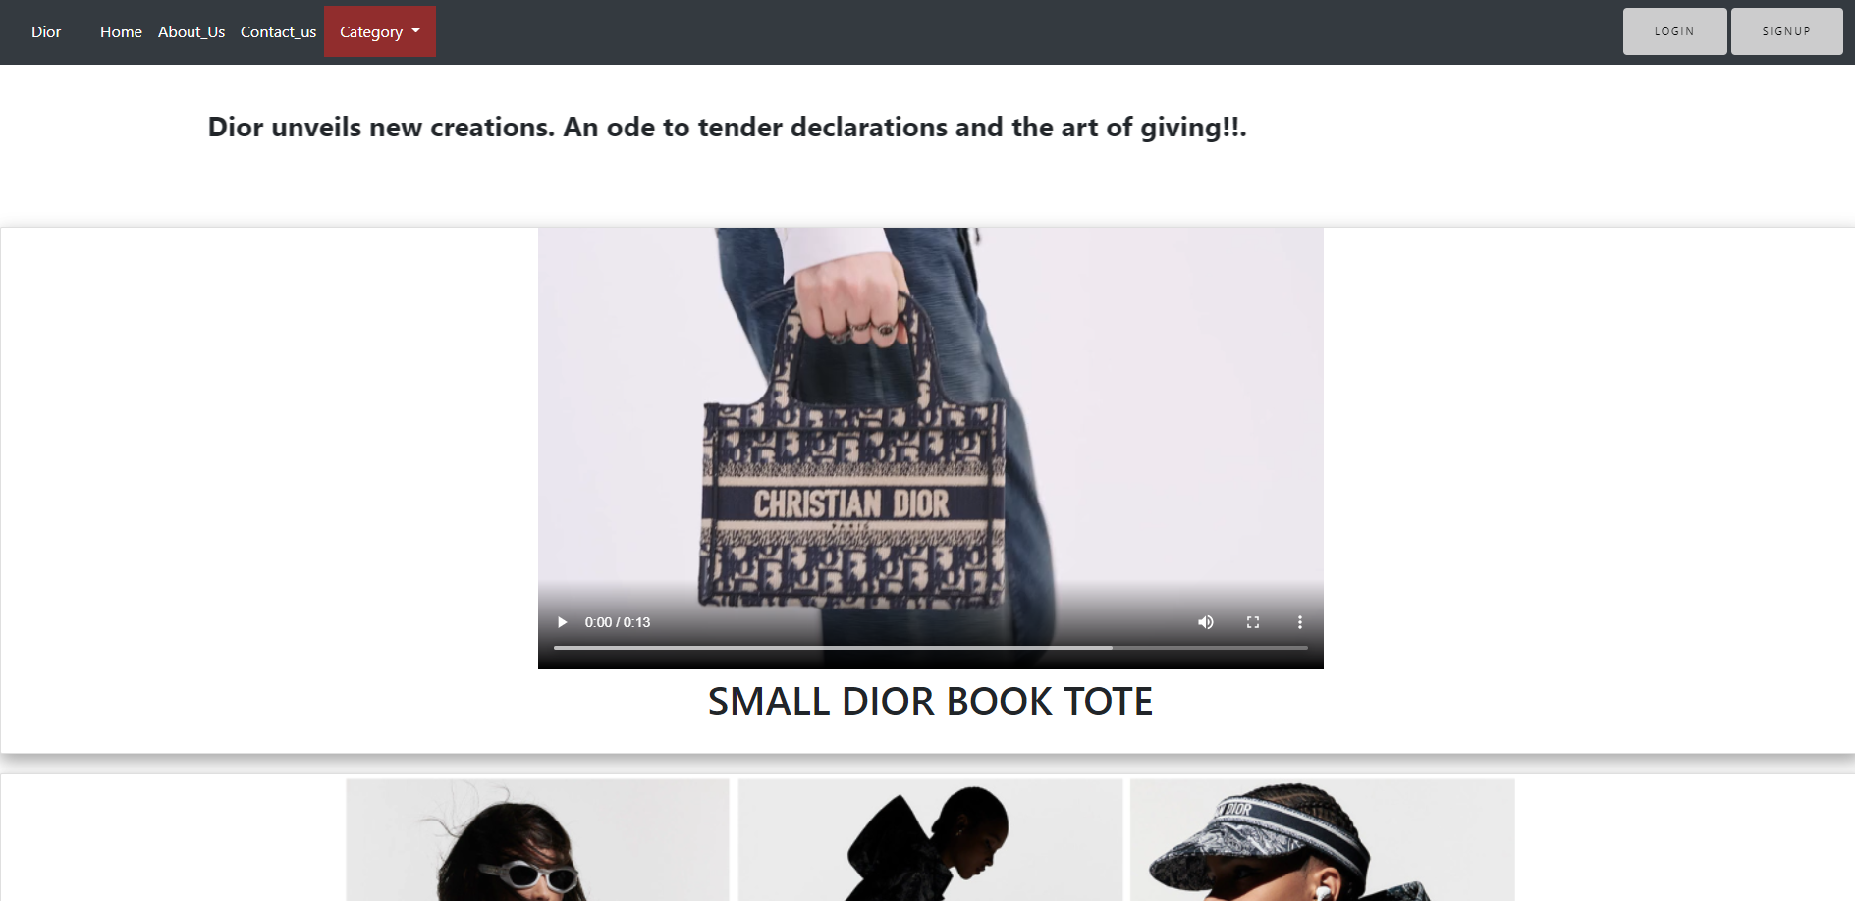

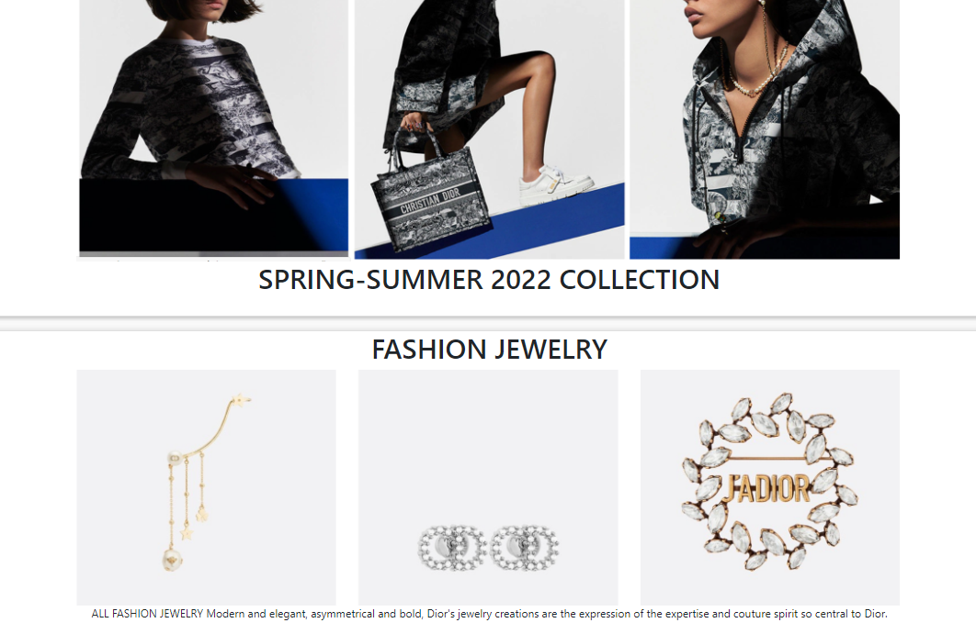

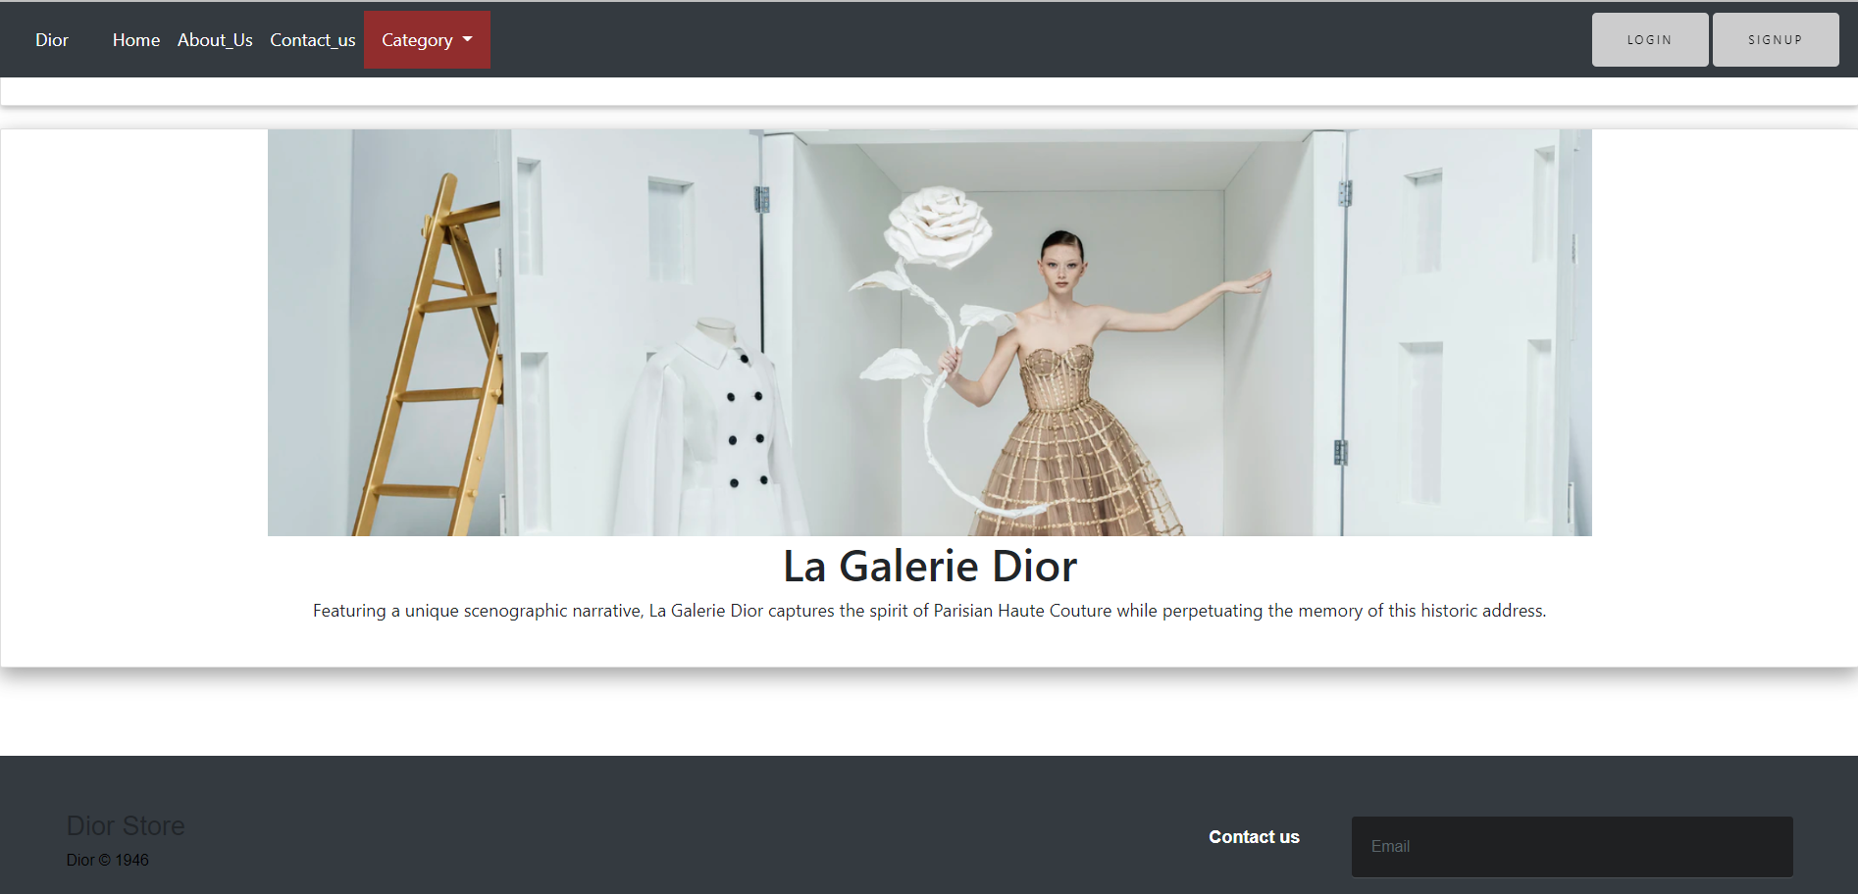

**Code:**

<!doctype html>

<html>

<head>

<meta charset=**"utf-8"**>

<meta name=**"viewport"** content=**"width=device-width, initial-scale=1, shrink-to-fit=no"**>

<link rel=**"stylesheet"** href=**"bootstrap.min.css"**>

<link rel=**"stylesheet"** href=**"css/font-awesome.min.css"**>

<link rel=**"stylesheet"** href=**"https://cdnjs.cloudflare.com/ajax/libs/font-awesome/4.7.0/css/font-awesome.min.css"**>

<script src=**"https://ajax.googleapis.com/ajax/libs/jquery/3.3.1/jquery.min.js"**></script>

<script src=**"https://maxcdn.bootstrapcdn.com/bootstrap/3.3.7/js/bootstrap.min.js"**></script>

<link rel=**"stylesheet"** href=**"style.css"**>

<title>**Dior**</title>

</head>

<body>

<nav class=**"navbar navbar-expand-md navbar-danger fixed-top bg-dark"**>

<a class=**"navbar-brand"** href=**"index.html"**>**Dior**</a>

<button class=**"navbar-toggler"** type=**"button"** data-toggle=**"collapse"** data-target=**"#navbarCollapse"** aria-controls=**"navbarCollapse"** aria-expanded=**"false"** aria-label=**"Toggle navigation"**>

<span class=**"navbar-toggler-icon"**></span>

</button>

<div class=**"collapse navbar-collapse"** id=**"navbarCollapse"**>

<ul class=**"navbar-nav mr-auto"**>

<li class=**"nav-item active"**>

<a class=**"nav-link"** href=**"index.html"**>**Home** <span class=**"sr-only"**>**(current)**</span></a>

</li>

<li class=**"nav-item"**>

<a class=**"nav-link"** href=**"About.html"**>**About_Us**</a>

</li>

<li class=**"nav-item"**>

<a class=**"nav-link"** href=**"contact.html"**>**Contact_us**</a>

</li>

<li class=**"dropdown"**>

<a class=**"dropdown-toggle"** data-toggle=**"dropdown"** href=**"#"**>**Category**

<span class=**"caret"**></span></a>

<ul class=**"dropdown-menu"**>

<li><a href=**"Women.html"**>**Women's Fashion**</a></li>

<li><a href=**"Men.html"**>**Men's Fashion**</a></li>

<div class=**"dropdown-divider"**> **Kides** & **Baby**</div>

<li><a href=**"index.html"**>**Fragrance** & **Beauty**</a></li>

<li><a href=**"index.html"**>**Make Ups**</a></li>

</ul>

</ul>

<form class=**"form-inline mt-2 mt-md-0"** action=**"login.html"**>

<button class=**"btn btn-outline-danger my-2 my-sm-0"** type=**"submit"**>**Login**</button>

</form>

<form class=**"form-inline mt-2 mt-md-0"** action=**"sign.html"**>

<button class=**"btn btn-outline-danger my-2 my-sm-0"** type=**"submit"**>**Signup**</button>

</form>

</div>

</nav>

<div id=**"carouselExampleIndicators"** class=**"carousel slide"** data-ride=**"carousel"**>

<ol class=**"carousel-indicators"**>

<li data-target=**"#carouselExampleIndicators"** data-slide-to=**"0"** class=**"active"**></li>

<li data-target=**"#carouselExampleIndicators"** data-slide-to=**"1"**></li>

</ol>

<div class=**"carousel-inner"**>

<div class=**"carousel-item active"**>

<img class=**"d-block w-100"** src=**"img/head.gif"** alt=**"First slide"**>

<div class=**"carousel-caption"**>

</div>

</div>

<div class=**"carousel-item"**>

<img class=**"d-block w-100"** src=**"img/head2.gif"** alt=**"Second slide"**>

<div class=**"carousel-caption"**>

</div>

</div>

</div>

<a class=**"carousel-control-prev"** href=**"#carouselExampleIndicators"** role=**"button"** data-slide=**"prev"**>

<span class=**"carousel-control-prev-icon"** aria-hidden=**"true"**></span>

<span class=**"sr-only"**>**Previous**</span>

</a>

<a class=**"carousel-control-next"** href=**"#carouselExampleIndicators"** role=**"button"** data-slide=**"next"**>

<span class=**"carousel-control-next-icon"** aria-hidden=**"true"**></span>

<span class=**"sr-only"**>**Next**</span>

</a>

</div>

<br><br>

<center>

<table width=**"100%"**><tbody><tr><td>

<marquee direction=**"right"**><font>

<h3><b>**Dior unveils new creations. An ode to tender declarations and the art of giving!!.**</b></h3></font></marquee>

</td></tr></tbody></table>

</center>

<br>

<br>

<br>

<!--carousel!-->

<center>

<div class=**"card"**>

<video width=**"800"** controls>

<source src=**"Women's Bags.mp4"** type=**"video/mp4"**>

<source src=**"1.ogg"** type=**"video/ogg"**>

</video>

<h1>**SMALL DIOR BOOK TOTE**</h1>

<br>

</div>

<div class=**"card"**>

<img src=**"img/W1.png"** width=**"1200px"**>

<h1>**SPRING-SUMMER 2022 COLLECTION**</h1>

<br>

</div>

<div class=**"card"**>

<h1>**FASHION JEWELRY**</h1>

<img src=**"img/jadior.png"** width=**"1200px"**>

<br>

<p>

**ALL FASHION JEWELRY**

**Modern and elegant, asymmetrical and bold, Dior's jewelry creations are the expression of the expertise and couture spirit so central to Dior.**

</p>

<br>

</div>

<div class=**"card"**>

<img src=**"img/Galerie.png"** width=**"1200px"**>

<h1>**La Galerie Dior**</h1>

<p>

**Featuring a unique scenographic narrative, La Galerie Dior captures the spirit of Parisian Haute Couture while perpetuating the memory of this historic address.**

</p>

<br>

</div>

</center>

</body>

<footer class=**"footer-distributed"**>

<div class=**"footer-left"**>

<h4>**Dior Store**</h4>

<p class=**"footer-company-name"** >**Dior** &copy; **1946**</p>

<div class=**"footer-icons"**>

<a href=**"#"**><i class=**"fa fa-facebook"**></i></a>

<a href=**"#"**><i class=**"fa fa-twitter"**></i></a>

<a href=**"#"**><i class=**"fa fa-linkedin"**></i></a>

<a href=**"#"**><i class=**"fa fa-github"**></i></a>

</div>

<br>

</div>

<div class=**"footer-right"**>

<p>**Contact us**

</p>

<form action=**"index.html"** method=**"post"**>

<input type=**"text"** name=**"email"** placeholder=**"Email"** />

<textarea name=**"message"** placeholder=**"Message"**></textarea>

<button class=**"btn btn-outline-danger my-2 my-sm-0"** type=**"submit"**>**Send**</button>

</form>

</div>

</footer>

<script src=**"js/jquery.min.js"**></script>

<script src=**"https://cdnjs.cloudflare.com/ajax/libs/popper.js/1.12.9/umd/popper.min.js"**></script>

<script src=**"js/bootstrap.min.js"**></script>

</body>

</html>

1. **Wen's Fashion**

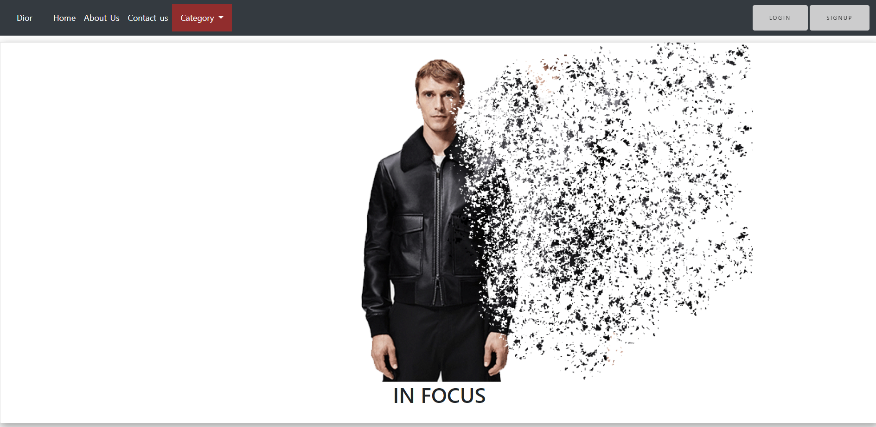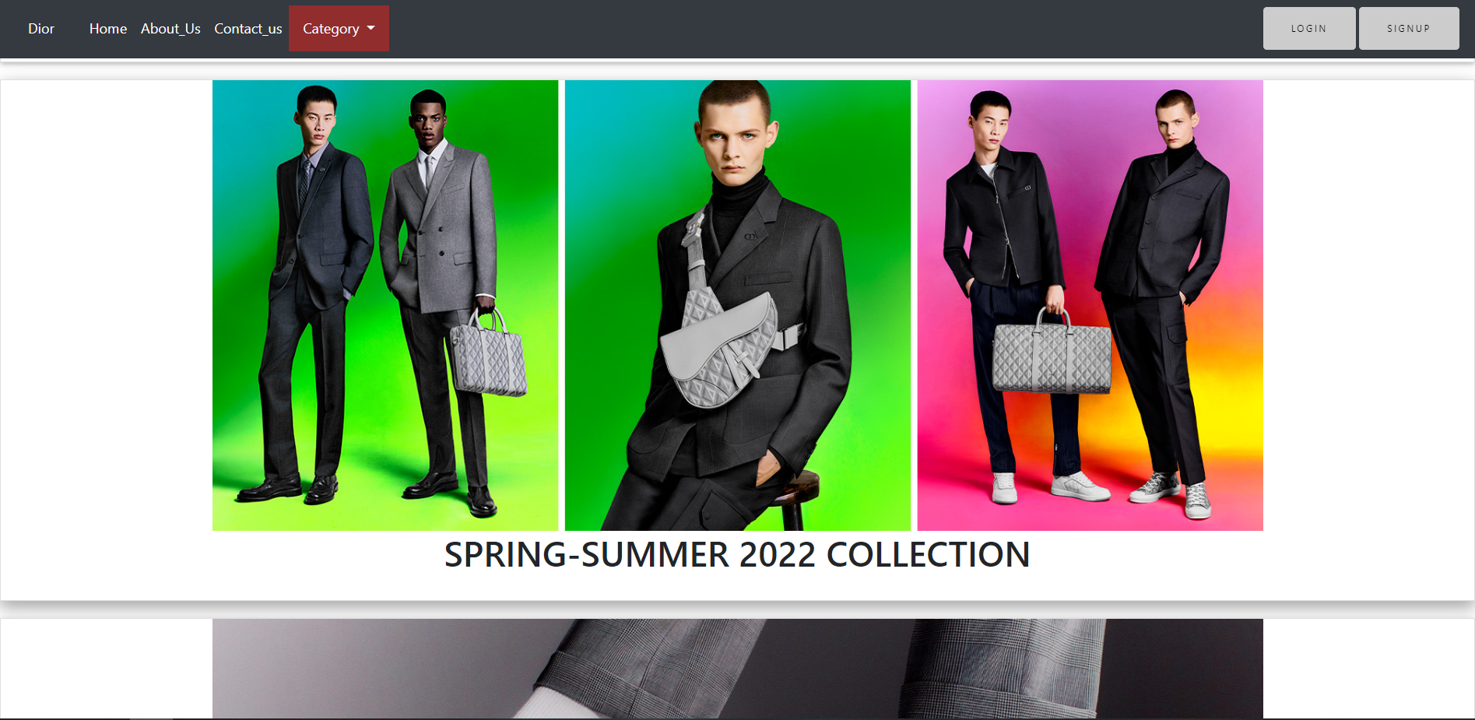

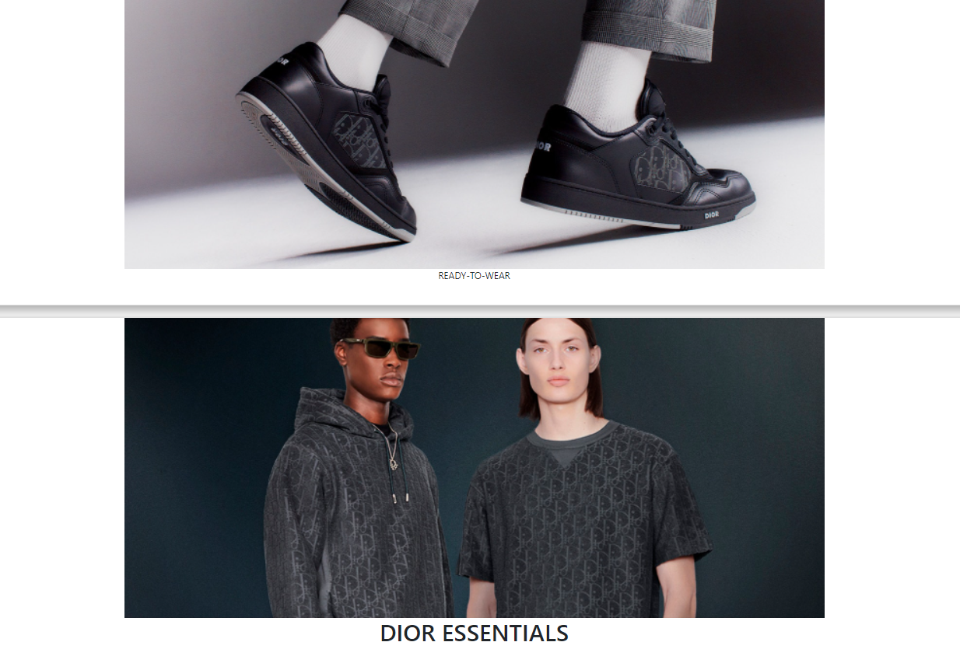

**Code:**

<!doctype html>

<html>

<head>

<meta charset=**"utf-8"**>

<meta name=**"viewport"** content=**"width=device-width, initial-scale=1, shrink-to-fit=no"**>

<link rel=**"stylesheet"** href=**"bootstrap.min.css"**>

<link rel=**"stylesheet"** href=**"css/font-awesome.min.css"**>

<link rel=**"stylesheet"** href=**"https://cdnjs.cloudflare.com/ajax/libs/font-awesome/4.7.0/css/font-awesome.min.css"**>

<script src=**"https://ajax.googleapis.com/ajax/libs/jquery/3.3.1/jquery.min.js"**></script>

<script src=**"https://maxcdn.bootstrapcdn.com/bootstrap/3.3.7/js/bootstrap.min.js"**></script>

<link rel=**"stylesheet"** href=**"style.css"**>

<title>**Dior**</title>

</head>

<body>

<nav class=**"navbar navbar-expand-md navbar-danger fixed-top bg-dark"**>

<a class=**"navbar-brand"** href=**"index.html"**>**Dior**</a>

<button class=**"navbar-toggler"** type=**"button"** data-toggle=**"collapse"** data-target=**"#navbarCollapse"** aria-controls=**"navbarCollapse"** aria-expanded=**"false"** aria-label=**"Toggle navigation"**>

<span class=**"navbar-toggler-icon"**></span>

</button>

<div class=**"collapse navbar-collapse"** id=**"navbarCollapse"**>

<ul class=**"navbar-nav mr-auto"**>

<li class=**"nav-item active"**>

<a class=**"nav-link"** href=**"index.html"**>**Home** <span class=**"sr-only"**>**(current)**</span></a>

</li>

<li class=**"nav-item"**>

<a class=**"nav-link"** href=**"About.html"**>**About_Us**</a>

</li>

<li class=**"nav-item"**>

<a class=**"nav-link"** href=**"contact.html"**>**Contact_us**</a>

</li>

<li class=**"dropdown"**>

<a class=**"dropdown-toggle"** data-toggle=**"dropdown"** href=**"#"**>**Category**

<span class=**"caret"**></span></a>

<ul class=**"dropdown-menu"**>

<li><a href=**"Women.html"**>**Women's Fashion**</a></li>

<li><a href=**"Men.html"**>**Men's Fashion**</a></li>

<div class=**"dropdown-divider"**> **Kides** & **Baby**</div>

<li><a href=**"index.html"**>**Fragrance** & **Beauty**</a></li>

<li><a href=**"index.html"**>**Make Ups**</a></li>

</ul>

</ul>

<form class=**"form-inline mt-2 mt-md-0"** action=**"login.html"**>

<button class=**"btn btn-outline-danger my-2 my-sm-0"** type=**"submit"**>**Login**</button>

</form>

<form class=**"form-inline mt-2 mt-md-0"** action=**"sign.html"**>

<button class=**"btn btn-outline-danger my-2 my-sm-0"** type=**"submit"**>**Signup**</button>

</form>

</div>

</nav>

<div id=**"carouselExampleIndicators"** class=**"carousel slide"** data-ride=**"carousel"**>

<ol class=**"carousel-indicators"**>

<li data-target=**"#carouselExampleIndicators"** data-slide-to=**"0"** class=**"active"**></li>

<li data-target=**"#carouselExampleIndicators"** data-slide-to=**"1"**></li>

</ol>

<div class=**"carousel-inner"**>

<div class=**"carousel-item active"**>

<img class=**"d-block w-100"** src=**"img/head.gif"** alt=**"First slide"**>

<div class=**"carousel-caption"**>

</div>

</div>

<div class=**"carousel-item"**>

<img class=**"d-block w-100"** src=**"img/head2.gif"** alt=**"Second slide"**>

<div class=**"carousel-caption"**>

</div>

</div>

</div>

<a class=**"carousel-control-prev"** href=**"#carouselExampleIndicators"** role=**"button"** data-slide=**"prev"**>

<span class=**"carousel-control-prev-icon"** aria-hidden=**"true"**></span>

<span class=**"sr-only"**>**Previous**</span>

</a>

<a class=**"carousel-control-next"** href=**"#carouselExampleIndicators"** role=**"button"** data-slide=**"next"**>

<span class=**"carousel-control-next-icon"** aria-hidden=**"true"**></span>

<span class=**"sr-only"**>**Next**</span>

</a>

</div>

<br><br>

<center>

<table width=**"100%"**><tbody><tr><td>

<marquee direction=**"right"**><font>

<h3><b>**Dior unveils new creations. An ode to tender declarations and the art of giving!!.**</b></h3></font></marquee>

</td></tr></tbody></table>

</center>

<br>

<br>

<br>

<!--carousel!-->

<center>

<div class=**"card"**>

<img src=**"img/EXPLOSION.png"** width=**"1200px"**>

<h1>**IN FOCUS**</h1>

<br>

</div>

<div class=**"card"**>

<img src=**"img/men1.jpg"** width=**"1200px"**>

<h1>**SPRING-SUMMER 2022 COLLECTION**</h1>

<br>

</div>

<div class=**"card"**>

<img src=**"img/men2.jpg"** width=**"1200px"**>

<br>

<p>

**READY-TO-WEAR**

</p>

<br>

</div>

<div class=**"card"**>

<img src=**"img/men3.jpg"** width=**"1200px"**>

<h1>**DIOR ESSENTIALS**</h1>

<br>

</div>

</center>

</body>

<footer class=**"footer-distributed"**>

<div class=**"footer-left"**>

<h4>**Dior Store**</h4>

<p class=**"footer-company-name"** >**Dior** &copy; **1946**</p>

<div class=**"footer-icons"**>

<a href=**"#"**><i class=**"fa fa-facebook"**></i></a>

<a href=**"#"**><i class=**"fa fa-twitter"**></i></a>

<a href=**"#"**><i class=**"fa fa-linkedin"**></i></a>

<a href=**"#"**><i class=**"fa fa-github"**></i></a>

</div>

<br>

</div>

<div class=**"footer-right"**>

<p>**Contact us**

</p>

<form action=**"index.html"** method=**"post"**>

<input type=**"text"** name=**"email"** placeholder=**"Email"** />

<textarea name=**"message"** placeholder=**"Message"**></textarea>

<button class=**"btn btn-outline-danger my-2 my-sm-0"** type=**"submit"**>**Send**</button>

</form>

</div>

</footer>

<script src=**"js/jquery.min.js"**></script>

<script src=**"https://cdnjs.cloudflare.com/ajax/libs/popper.js/1.12.9/umd/popper.min.js"**></script>

<script src=**"js/bootstrap.min.js"**></script>

</body>

</html>

1. **Login**

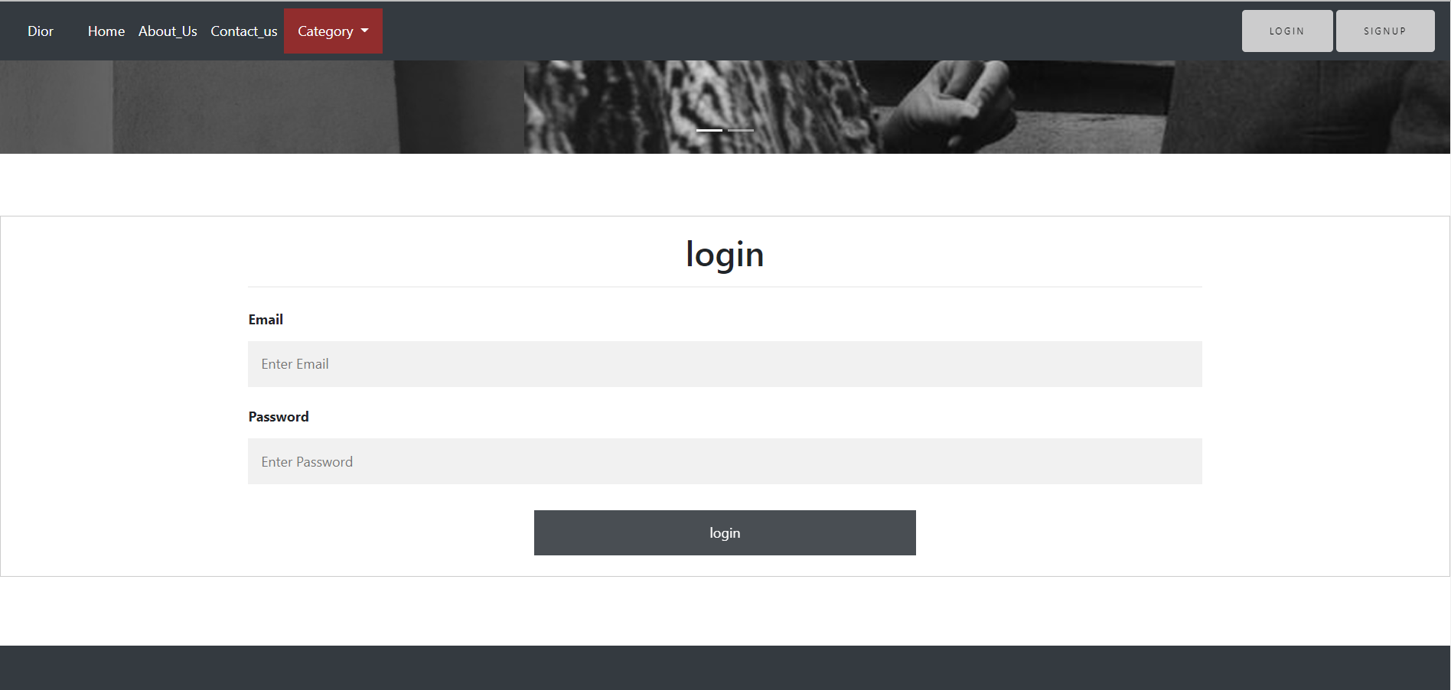

**Code:**

<!doctype html>

<html>

<head>

<meta charset=**"utf-8"**>

<meta name=**"viewport"** content=**"width=device-width, initial-scale=1, shrink-to-fit=no"**>

<link rel=**"stylesheet"** href=**"bootstrap.min.css"**>

<link rel=**"stylesheet"** href=**"css/font-awesome.min.css"**>

<link rel=**"stylesheet"** href=**"https://cdnjs.cloudflare.com/ajax/libs/font-awesome/4.7.0/css/font-awesome.min.css"**>

<script src=**"https://ajax.googleapis.com/ajax/libs/jquery/3.3.1/jquery.min.js"**></script>

<script src=**"https://maxcdn.bootstrapcdn.com/bootstrap/3.3.7/js/bootstrap.min.js"**></script>

<link rel=**"stylesheet"** href=**"style.css"**>

<title>**Dior**</title>

</head>

<body>

<nav class=**"navbar navbar-expand-md navbar-danger fixed-top bg-dark"**>

<a class=**"navbar-brand"** href=**"index.html"**>**Dior**</a>

<button class=**"navbar-toggler"** type=**"button"** data-toggle=**"collapse"** data-target=**"#navbarCollapse"** aria-controls=**"navbarCollapse"** aria-expanded=**"false"** aria-label=**"Toggle navigation"**>

<span class=**"navbar-toggler-icon"**></span>

</button>

<div class=**"collapse navbar-collapse"** id=**"navbarCollapse"**>

<ul class=**"navbar-nav mr-auto"**>

<li class=**"nav-item active"**>

<a class=**"nav-link"** href=**"index.html"**>**Home** <span class=**"sr-only"**>**(current)**</span></a>

</li>

<li class=**"nav-item"**>

<a class=**"nav-link"** href=**"About.html"**>**About_Us**</a>

</li>

<li class=**"nav-item"**>

<a class=**"nav-link"** href=**"contact.html"**>**Contact_us**</a>

</li>

<li class=**"dropdown"**>

<a class=**"dropdown-toggle"** data-toggle=**"dropdown"** href=**"#"**>**Category**

<span class=**"caret"**></span></a>

<ul class=**"dropdown-menu"**>

<li><a href=**"Women.html"**>**Women's Fashion**</a></li>

<li><a href=**"Men.html"**>**Men's Fashion**</a></li>

<div class=**"dropdown-divider"**> **Kides** & **Baby**</div>

<li><a href=**"index.html"**>**Fragrance** & **Beauty**</a></li>

<li><a href=**"index.html"**>**Make Ups**</a></li>

</ul>

</ul>

<form class=**"form-inline mt-2 mt-md-0"** action=**"login.html"**>

<button class=**"btn btn-outline-danger my-2 my-sm-0"** type=**"submit"**>**Login**</button>

</form>

<form class=**"form-inline mt-2 mt-md-0"** action=**"sign.html"**>

<button class=**"btn btn-outline-danger my-2 my-sm-0"** type=**"submit"**>**Signup**</button>

</form>

</div>

</nav>

<div id=**"carouselExampleIndicators"** class=**"carousel slide"** data-ride=**"carousel"**>

<ol class=**"carousel-indicators"**>

<li data-target=**"#carouselExampleIndicators"** data-slide-to=**"0"** class=**"active"**></li>

<li data-target=**"#carouselExampleIndicators"** data-slide-to=**"1"**></li>

</ol>

<div class=**"carousel-inner"**>

<div class=**"carousel-item active"**>

<img class=**"d-block w-100"** src=**"img/head.gif"** alt=**"First slide"**>

<div class=**"carousel-caption"**>

</div>

</div>

<div class=**"carousel-item"**>

<img class=**"d-block w-100"** src=**"img/head2.gif"** alt=**"Second slide"**>

<div class=**"carousel-caption"**>

</div>

</div>

</div>

<a class=**"carousel-control-prev"** href=**"#carouselExampleIndicators"** role=**"button"** data-slide=**"prev"**>

<span class=**"carousel-control-prev-icon"** aria-hidden=**"true"**></span>

<span class=**"sr-only"**>**Previous**</span>

</a>

<a class=**"carousel-control-next"** href=**"#carouselExampleIndicators"** role=**"button"** data-slide=**"next"**>

<span class=**"carousel-control-next-icon"** aria-hidden=**"true"**></span>

<span class=**"sr-only"**>**Next**</span>

</a>

</div>

<br>

<br>

<br>

<form action=**"index.html"** style=**"border:1px solid #ccc"**>

<div class=**"container"**>

<center><h1>**login**</h1></center>

<hr>

<label for=**"email"**><b>**Email**</b></label>

<input type=**"text"** placeholder=**"Enter Email"** name=**"email"** required>

<label for=**"psw"**><b>**Password**</b></label>

<input type=**"password"** placeholder=**"Enter Password"** name=**"psw"** required>

<div class=**"clearfix"**>

<center>

<button type=**"submit"** class=**"signupbtn"**>**login**</button>

</center>

</div>

</div>

</form>

<footer class=**"footer-distributed"**>

<div class=**"footer-left"**>

<h4>**Dior Store**</h4>

<p class=**"footer-company-name"** >**Dior** &copy; **1946**</p>

<div class=**"footer-icons"**>

<a href=**"#"**><i class=**"fa fa-facebook"**></i></a>

<a href=**"#"**><i class=**"fa fa-twitter"**></i></a>

<a href=**"#"**><i class=**"fa fa-linkedin"**></i></a>

<a href=**"#"**><i class=**"fa fa-github"**></i></a>

</div>

<br>

</div>

<div class=**"footer-right"**>

<p>**Contact us**

</p>

<form action=**"index.html"** method=**"post"**>

<input type=**"text"** name=**"email"** placeholder=**"Email"** />

<textarea name=**"message"** placeholder=**"Message"**></textarea>

<button class=**"btn btn-outline-danger my-2 my-sm-0"** type=**"submit"**>**Send**</button>

</form>

</div>

</footer>

<script src=**"js/jquery.min.js"**></script>

<script src=**"https://cdnjs.cloudflare.com/ajax/libs/popper.js/1.12.9/umd/popper.min.js"**></script>

<script src=**"js/bootstrap.min.js"**></script>

</body>

</html>

1. **Sign up**

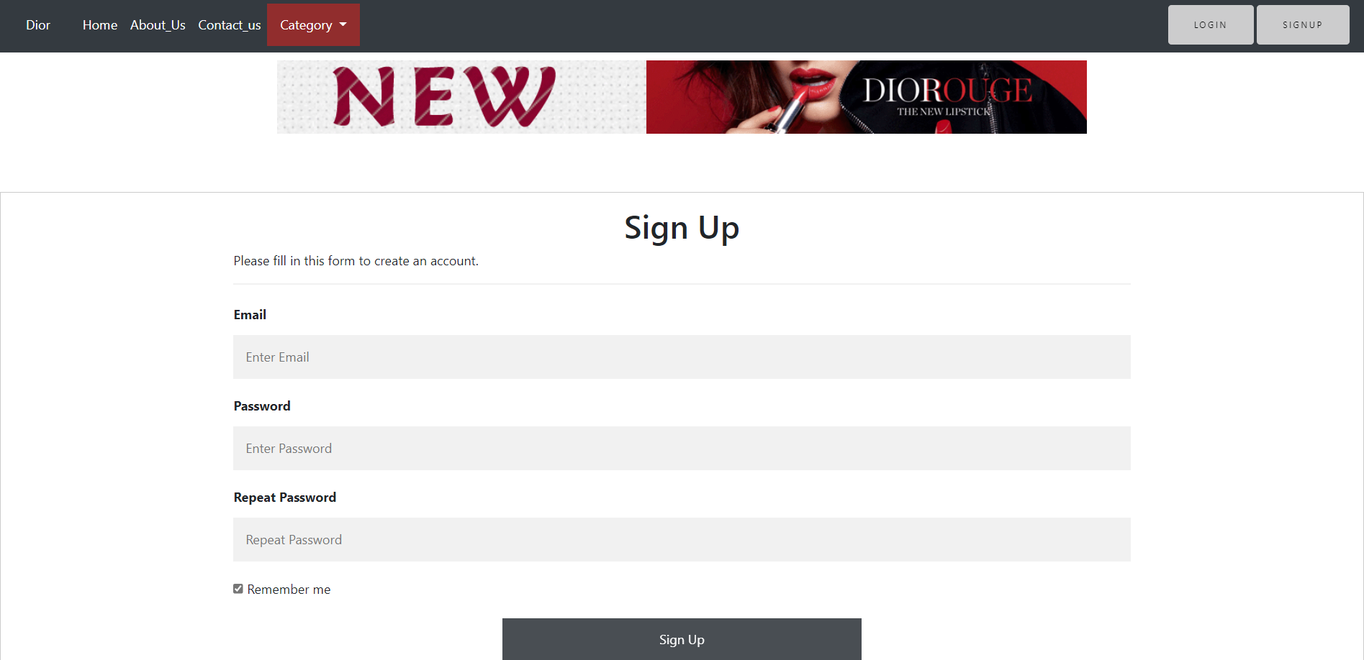

**Code:**

<!doctype html>

<html>

<head>

<meta charset=**"utf-8"**>

<meta name=**"viewport"** content=**"width=device-width, initial-scale=1, shrink-to-fit=no"**>

<link rel=**"stylesheet"** href=**"bootstrap.min.css"**>

<link rel=**"stylesheet"** href=**"css/font-awesome.min.css"**>

<link rel=**"stylesheet"** href=**"https://cdnjs.cloudflare.com/ajax/libs/font-awesome/4.7.0/css/font-awesome.min.css"**>

<script src=**"https://ajax.googleapis.com/ajax/libs/jquery/3.3.1/jquery.min.js"**></script>

<script src=**"https://maxcdn.bootstrapcdn.com/bootstrap/3.3.7/js/bootstrap.min.js"**></script>

<link rel=**"stylesheet"** href=**"style.css"**>

<title>**Dior**</title>

</head>

<body>

<nav class=**"navbar navbar-expand-md navbar-danger fixed-top bg-dark"**>

<a class=**"navbar-brand"** href=**"index.html"**>**Dior**</a>

<button class=**"navbar-toggler"** type=**"button"** data-toggle=**"collapse"** data-target=**"#navbarCollapse"** aria-controls=**"navbarCollapse"** aria-expanded=**"false"** aria-label=**"Toggle navigation"**>

<span class=**"navbar-toggler-icon"**></span>

</button>

<div class=**"collapse navbar-collapse"** id=**"navbarCollapse"**>

<ul class=**"navbar-nav mr-auto"**>

<li class=**"nav-item active"**>

<a class=**"nav-link"** href=**"index.html"**>**Home** <span class=**"sr-only"**>**(current)**</span></a>

</li>

<li class=**"nav-item"**>

<a class=**"nav-link"** href=**"About.html"**>**About_Us**</a>

</li>

<li class=**"nav-item"**>

<a class=**"nav-link"** href=**"contact.html"**>**Contact_us**</a>

</li>

<li class=**"dropdown"**>

<a class=**"dropdown-toggle"** data-toggle=**"dropdown"** href=**"#"**>**Category**

<span class=**"caret"**></span></a>

<ul class=**"dropdown-menu"**>

<li><a href=**"Women.html"**>**Women's Fashion**</a></li>

<li><a href=**"Men.html"**>**Men's Fashion**</a></li>

<div class=**"dropdown-divider"**> **Kides** & **Baby**</div>

<li><a href=**"index.html"**>**Fragrance** & **Beauty**</a></li>

<li><a href=**"index.html"**>**Make Ups**</a></li>

</ul>

</ul>

<form class=**"form-inline mt-2 mt-md-0"** action=**"login.html"**>

<button class=**"btn btn-outline-danger my-2 my-sm-0"** type=**"submit"**>**Login**</button>

</form>

<form class=**"form-inline mt-2 mt-md-0"** action=**"sign.html"**>

<button class=**"btn btn-outline-danger my-2 my-sm-0"** type=**"submit"**>**Signup**</button>

</form>

</div>

</nav>

<div id=**"carouselExampleIndicators"** class=**"carousel slide"** data-ride=**"carousel"**>

<ol class=**"carousel-indicators"**>

<li data-target=**"#carouselExampleIndicators"** data-slide-to=**"0"** class=**"active"**></li>

<li data-target=**"#carouselExampleIndicators"** data-slide-to=**"1"**></li>

</ol>

<div class=**"carousel-inner"**>

<div class=**"carousel-item active"**>

<img class=**"d-block w-100"** src=**"img/head.gif"** alt=**"First slide"**>

<div class=**"carousel-caption"**>

</div>

</div>

<div class=**"carousel-item"**>

<img class=**"d-block w-100"** src=**"img/head2.gif"** alt=**"Second slide"**>

<div class=**"carousel-caption"**>

</div>

</div>

</div>

<a class=**"carousel-control-prev"** href=**"#carouselExampleIndicators"** role=**"button"** data-slide=**"prev"**>

<span class=**"carousel-control-prev-icon"** aria-hidden=**"true"**></span>

<span class=**"sr-only"**>**Previous**</span>

</a>

<a class=**"carousel-control-next"** href=**"#carouselExampleIndicators"** role=**"button"** data-slide=**"next"**>

<span class=**"carousel-control-next-icon"** aria-hidden=**"true"**></span>

<span class=**"sr-only"**>**Next**</span>

</a>

</div>

<!--carousel!-->

<br>

<center>

<img src=**"img/banner.gif"**>

</center>

<br>

<br>

<br>

<form action=**"reg.php"** style=**"border:1px solid #ccc"**>

<div class=**"container"**>

<center><h1>**Sign Up**</h1></center>

<p>**Please fill in this form to create an account.**</p>

<hr>

<label for=**"email"**><b>**Email**</b></label>

<input type=**"text"** placeholder=**"Enter Email"** name=**"email"** required>

<label for=**"psw"**><b>**Password**</b></label>

<input type=**"password"** placeholder=**"Enter Password"** name=**"password"** required>

<label for=**"psw-repeat"**><b>**Repeat Password**</b></label>

<input type=**"password"** placeholder=**"Repeat Password"** name=**"password-repeat"** required>

<label>

<input type=**"checkbox"** checked=**"checked"** name=**"remember"** style=**"margin-bottom:15px"**> **Remember me**

</label>

<div class=**"clearfix"**>

<center>

<button type=**"submit"** class=**"signupbtn"**>**Sign Up**</button>

</center>

</div>

</div>

</form>

<footer class=**"footer-distributed"**>

<div class=**"footer-left"**>

<h4>**Dior Store**</h4>

<p class=**"footer-company-name"** >**Dior** &copy; **1946**</p>

<div class=**"footer-icons"**>

<a href=**"#"**><i class=**"fa fa-facebook"**></i></a>

<a href=**"#"**><i class=**"fa fa-twitter"**></i></a>

<a href=**"#"**><i class=**"fa fa-linkedin"**></i></a>

<a href=**"#"**><i class=**"fa fa-github"**></i></a>

</div>

<br>

</div>

<div class=**"footer-right"**>

<p>**Contact us**

</p>

<form action=**"index.html"** method=**"post"**>

<input type=**"text"** name=**"email"** placeholder=**"Email"** />

<textarea name=**"message"** placeholder=**"Message"**></textarea>

<button class=**"btn btn-outline-danger my-2 my-sm-0"** type=**"submit"**>**Send**</button>

</form>

</div>

</footer>

<script src=**"js/jquery.min.js"**></script>

<script src=**"https://cdnjs.cloudflare.com/ajax/libs/popper.js/1.12.9/umd/popper.min.js"**></script>

<script src=**"js/bootstrap.min.js"**></script>

</body>

</html>